



**PATE’S GRAMMAR SCHOOL**

**COMPUTING DEPARTMENT**

**Unit 3/4 – Programming Project**

CANDIDATE NAME

Sri Abhiram Vemulapalli

EXAM NUMBER

7079

**Table of Contents**

(1) Analysis of the problem (10 Marks) 3

(i) problem definition 3

(ii) Stakeholders 5

(iii) RESEARCH THE PROBLEM 6

(iv) SPECIFIY THE PROPOSED SOLUTION 9

(2) Design OF THE SOLUTION [15 marks] 11

(i) DECOMPOSE THE PROBLEM 11

(ii) DESCRIBE THE SOLUTION 12

(iii) DESCRIBE THE APPROACH TO TESTING 13

(3) DEVELOPING THE SOLUTION (25 mARKS) 14

(i) INTERATIVE DEVELOPMENT PROCESS 14

(ii) TESTING TO INFORM DEVELOPMENT 15

(4) EVALUATION (20 mARKS) 16

(I) TESTING TO INFORM EVALUATION 16

(II) SUCCESS OF THE SOLUTION 17

(III) DESCRIBE THE FINAL PRODUCT 18

(IV) MAINTENANCE AND DEVELOPMENT 19

APPENDIX A - BIBLIOGRAPHY 20

# (1) Analysis of the problem (10 Marks)

## (i) problem definition

*(a) Describe and justify the features that make the problem solvable by computational methods.*

*(b) Explain why the problem is amenable to a computational approach.*

Describe your solution. What is it? Why do they need a solution? Why is better than the solution that they currently have or why am I going to emulate a current solution for my clients?

In this section you must talk about why your solution is suited to a computer. You Can’t just say “well it’s a website, so it can’t be done on paper!”. You must compare to non-computer methods i.e. creating a website for Donuts-r-us means that they will be able to store client details, target advertising, have a much wider audience than simply creating a poster.

You could also say things that a computer is really good at, such as providing multimedia, storing records, analysis of orders & invoices, tracking systems across time, allowing levels of difficulty. You could mention things such as your solution can be developed in a modular manner – i.e. customers, orders, products or sprites, each object (in the game), levels, introduction, help screens etc.

You can also mention things like repeated code – such as several modules being similar (add customer, add employee or baddie number 1, baddie number 2 sharing similar properties). You could mention the use of libraries and that you won’t have to code everything yourself from scratch.

**Example of the solution description**

*“The shoot 'em up is a subgenre of the shooter genre of video games. In a shoot 'em up, the player character engages in a lone assault, often in a spacecraft or aircraft, shooting large numbers of enemies while dodging their attacks. The genre's origins can be traced back to Spacewar!!, one of the earliest computer games, developed in 1962 and eventually released in amusement arcades in the early 1970s. However, Tomohiro Nishikado, creator of Space Invaders, is generally credited with inventing the genre.*

*These games are usually viewed from a top-down or side-view perspective, and players must use ranged weapons to take action at a distance. The player's avatar is typically a vehicle under constant attack. Thus, the player's goal is to shoot as quickly as possible anything that moves or threatens him. In some games, the player's character can withstand some damage; in others, a single hit will result in his destruction. The main skills required in shoot 'em ups are fast reactions and memorising enemy attack patterns. Some games feature overwhelming numbers of enemy projectiles, and the player has to memorise their patterns to survive. These games belong to one of the fastest-paced video game genres. Large numbers of enemy characters are typically featured. These enemies may behave in a certain way dependent on their type, or attack in formations that the player can learn to predict. The basic gameplay tends to be straightforward and many games offset this with boss battles and a variety of weapons. Shoot 'em ups rarely have realistic physics. Characters can instantly change direction with no inertia, and projectiles move in a straight line at constant speeds. The player's character may collect "power-ups" which may afford the character greater protection, an "extra life", or upgraded weaponry. Different weapons are often suited to different enemies, but these games seldom keep track of ammunition. As such, players tend to fire indiscriminately, and their weapons only damage legitimate targets.*

*Typical games in this genre include: Space invaders, Project starfighter, Galaxian, Defender and Resogun.”*

**Problem Definition**

Cricket is a very unpredictable game and there are many factors that play into a team’s success/loss. Predicting cricket matches is important as it allows analysis to be done on the strengths and weaknesses of a team, and allows the users to be able to vary factors that may change the chance of success of a team. As of right now, predicting the outcome of these matches is a very long and painstaking process, as it is done by hand using Cricinfo, Wisden etc. This means that it takes a very long time, and is prone to numerical mistakes. Computer software that does this is normally paid, or does not include many additional features, just a chance of winning that is normally always skewed to 50% and inaccurate.. Hence, I will be creating an application that the end user can download to predict the outcome, along with other features that other software may not have, such as innings simulation and the ability to customise a lot of parameters, such as the players in each time, the venue etc.

My solution will mainly use machine learning and data analytics to predict the answer, and will make use of web scraping to find news articles and opinions from trusted sources that will provide a reliable estimate. I will use a regression model, to look at past results to provide a numerical “strength of the team”, where more recent results are weighted more heavily than past results, while also incorporating a randomiser to account for random events. This problem is suited to a computational approach as the software must be built on a computer, and a large amount of data must be processed and analysed which cannot be done by hand.

**Why can a computational approach be used?**

The main reason a computational approach is used underpins the problem itself. Since analysis by hand using Wisden and other articles take too long, I will develop this software so that the computer can do all of the calculations very quickly and save time for the user. This is only possible due to the speed of modern processors at processing array data. This also allows for simultaneous processing to happen, so more than one calculation can be done at once through the use of pipelining, which is not possible with human analysis. Human analysis is also prone to a lot of mistakes, which can be completely prevented by using a computer, provided that the inputs are correct. The large amount of data that needs to be analysed further suggests that a computational approach is required. Computers excel at array processing, which allows this to be done very quickly, as well as sorting and searching for data. This large amount of data also needs to be stored. This can be stored either on the cloud or locally, both of which take up a very small amount of physical space compared to paper copies, and allows for the use of databases to improve efficiency.

Storage is another key part of the solution that reinforces the strength of a computational solution. The use of database handling would allow me to provide an interface for the user, allowing them to change various factors manually such as the weather.

As the problem lends itself to a computational approach, there are a variety of computational thinking techniques that can make the problem easier to solve.

**Computational Thinking Strategies**

**Decomposition**

I can split my program into different modules, and use the divide and conquer method to work on these independently. The GUI, regression and analysis can be done in different modules which would make the development process more streamlined.

**Divide and Conquer**

The solution can also be developed in independent modules, such as the machine learning model, GUI, database storage all being modules that can be worked on independently and then incorporated into the main program to maintain readability and structure. This is suited to a computational approach as different files and programs can be built and coded separately, all of which can be imported as modules/libraries into the main program. The use of modules and libraries also allows for lots of code to be reused, which can save time and processing power.

**Abstraction**

In a real cricket match, there are a lot of factors that play a marginally small role in the outcome of a match. This can include the wellbeing of players, time etc. These factors would be practically impossible to emulate in my program, and hence I will only include factors that have a chance to play a vital role in the outcome. Furthermore, the machine learning algorithm and the analysis can be hidden from the user so there is no need to develop a GUI for these parts, only for showing the results.

## (ii) Stakeholders

*(a) Identify and describe those who will have an interest in the solution explaining how the solution is appropriate to their needs (this may be named individuals, groups or persona that describes the target end user).*

Who is it for? What organisation/genre of person. Give some detail e.g. “I am designing a game to appeal to 14-16 year olds who are interested in sci-fi” or “My organization is a restaurant in the Cotswold village of Moreton-in-Marsh, they serve 14 customer per day and have 3 main meals…”.

It’s far easier if you can name a particular person who will providing feedback as you develop your solution. This means that they can comment on your work – ALL the way through your project. So pick someone that you can nag!

In this section, if you have an organisation you need to talk about what they currently do, why it isn’t working and how they intend to use your system in the future. How will it help them? Will it save time, combat existing inefficiencies? Allow them to track data? Stop redundant data? Allow multiple access to data? Allow backups etc. You must be detailed, don’t just say that it will improve things, tell me what things. You could also include things such as cooperate logos, colours etc

If you have a game for a particular audience, make sure that you have thought about what you can and can’t include in your game. If your audience is young, you will have to think about colour schemes, language, playability the kind of things that they can and cannot do. If your audience is older you also need to include things like why they would like the game, have they always wanted a game that….? Are they the greatest fan of …..? You may want to cross reference your work with the PEGI rating system. You may want to mention that you will have to design the levels to increase in difficulty or even have a tutorial level that presents instructions to users (pants for under 8s, but useful for over 16s).

You could also talk about the kind of platform that you are writing for. Does your organization have three laptops? Does it have two desktops? Are you designing for a phone, tablet? Are there resolutions that you can or can’t use?

**Stakeholders**

The main stakeholders of this program would be my end users with access to a computer. Since there is no potentially harmful content in my project, there will be no age limit to be able to access the program. The user interface would be very simple, and all of the features will be very easy to use, so experience with a computer is not required. The hardware requirements for my stakeholder is that they would have to have to be able to access a modern computer that is connected to the internet, with input and output peripherals, such as a monitor, mouse and keyboard.

I have selected a group of 4 stakeholders that I can easily contact, that regularly follow cricket. 3 of them are in the 16-18 demographic and follow cricket to varying levels. They are Alex Varghese, Yachna Dhir and Guneet Gill, who have mostly used some sort of prediction or fantasy app before (fantasy cricket world cup, cricbuzz etc). Guneet also plays cricket regularly, and I can ask him about how various factors play into the outcome, venue, toss, dew etc as he has experience playing. The last stakeholder is my father, who is an avid supporter of the Indian cricket team. He is also a software engineer, so I can regularly ask him about the features that would make a program lightweight and easy to use.

I will be sending stakeholders forms regularly, that they can use to provide any input into the development process, while also providing initial conditions at the beginning of the development process.

**Stakeholder Survey**

I sent a survey to each of my stakeholders asking them 13 questions that will help me define the functionality and requirements for the program.

**Question 1 - How often do you use fantasy apps?**

Everyone responded weekly for this question, showing that there is high demand for these kinds of apps, and that my project would be used regularly by my stakeholders

**Question 2 - How often do you follow cricket?**

The majority responded daily, while 1 person responded weekly and 1 yearly. From this, I can diversify my stakeholders, and make it such that it will be interesting to people who don't follow cricket on a daily basis. And hence, I will have to minimise the use of jargon in my program, so that every end user can understand it, as some may not be that knowledgeable about cricket.

**Question 3 - What is your age?**

The majority were 16-18, suggesting that I need to tailor my program to meet the requirements and characteristics of the adult/young adult demographic.

**Question 4 - Would you be interested in a feature that predicts the “impact player” for a given match?**

Everyone answered yes to this question, suggesting that it is a highly demanded feature, and I will put it into a high priority for functions of my program.

**Question 5 - What platform would you prefer?**

3 people responded that they would prefer a website, as no installation and compatibility is required, and they can immediately navigate to the website from their browser instead of having to open a new application. Hence, I will create my program on a website.

**Question 6 - Would you be interested in being able to simulate every ball in a match?**

3 responded no, as they would find it too time consuming. To make my program lightweight and streamlined, I decided to not include this feature.

**Question 7 - Would you want a scorecard displayed at the end of a match?**

The majority responded yes to this question, and hence I will create a feature that will output the scorecard as a downloadable txt to the user so they can view who scored the runs, who took the wickets etc.

**Question 8 - Have you used a cricket predictor before?**

Most people said no to this question, or simply said google win prediction. This indicated that there was no exposure for accurate win predictors, unlike the google one. Because of this, I will also have to make my program very easy to understand and use as they have never used a predicting software before.

**Question 9 - Would you be interested in a feature where you can drag and drop players from different teams?**

Everyone answered yes to this question, suggesting that is a highly demanded feature. This will introduce more functionality into the program and can mean that end users will spend more time with the program experimenting with different teams.

**Question 10 - Would you want to manually vary pitch conditions?**

Most people said that they wanted to vary the toss and venue, as they play the largest role of the external factors when deciding on the outcome of the match. 2 people also said they would want to vary the temperature and pitch condition, but it is likely that this could fall under the various characteristics of each venue. Only 1 person wanted to be able to vary the dew factor in the program, so I will not include that in the program.

**Question 11 - Are you paying for any of this prediction software?**

Everyone responded no, and hence I will base my research off free software to make sure that nothing is locked behind paywalls and such when finding good and bad parts of similar software in my research.

**Question 12 - What colour scheme do you want for the software?**

A lot of responses of blue and white resulted, with a large number also preferring a black colour scheme. To make sure that every stakeholder has a colour scheme they would like in the program, I have decided to make my colour scheme a combination of blue, white and black.

**Question 13 - Are there any other features that you would like?**

3 responded with new features they would like to see in the program. I had one response that wanted the resultant scorecard to be emailed to them after they have simulated a match, which could be useful if they want to look at it on a different system. 2 people responded that they wanted my program to be able to predict the best possible fantasy team from all the player pool. This would add a lot more functionality and could help them with choosing a fantasy team in the actual fantasy competitions. Lastly, 1 person wanted the program to be a fantasy app that includes prediction, however, I felt that this is straying away from the problem and would be too difficult to maintain. Therefore, I decided to not include a fantasy game inside my program.

With my survey, it allowed me to specify initial requirements that would help me in starting the development process on my first prototype.

**Stakeholder access**

To prevent my code from being accessed and biased, I will include some rules that I will make the program to follow.

* None of the end users will be able to make changes to the dataset, as the main aspects will be hidden in the source code, and hence only the results will be shown to the user. This is to stop the results from being skewed and biased on purpose by the end users.
* The database from which the data is retrieved from will be stored centrally as a result.

## (iii) RESEARCH THE PROBLEM

*(a) Research the problem and solutions to similar problems to identify and justify suitable approaches to a solution.*

*(b) Describe the essential features of a computational solution explaining these choices.*

*(c) Explain the limitations of the proposed solution.*

When you conduct your research you will have to add detail. For creating a game, this is relatively simple. Think about colours, levels, playability, what did you like, what did you hate, what can you include, what is just beyond your capability, what extensions could you add. You must describe the games that you test and then evaluate each one – I would suggest that three would be sufficient. Go into detail - What are the controls? Who are the enemies? What is the aim? What is the jeopardy? How do you progress? Are there lives? Is there a score? What are the graphics? What platforms is it available for? Are there sounds? DO you have weapons & how are they used?

If you are looking at industrial software, this can be harder. If you can get hold of demo software, then use this and see how it works. You may have to think slightly laterally. For example, if you are developing a booking system for theatre tickets, you may have to look at similar industries, such as cinemas, events & travel. You may have to rely in the blurb that they have on the website – with video adverts etc. Include screenshots so that your examiner gets an idea of the software that you have been researching. But your analysis will be similar to those looking at games. What features does it have, which can you do, which can’t you do, which do you like and those that you don’t.

You must also mention what you cannot do – creating a limitations heading would be good. What will you be unable to do & why. E.g. I will develop my system for a Windows environment, because I only have access to Windows based computers. I will have to limit my levels to 7, because I won’t have time for 300. I will have to encrypt my data using a simple Ceaser Cypher, because it will take too long to write an encryption algorithm.

You must also include some information about the computational solution. Here is an example:

### *Abstraction and visualisation*

* *What are the key objects in your game?*
* *What sprites, symbols, icons or font sets will be needed?*
* *Are there further lines of investigation to follow?*

### *Thinking ahead*

* *•What will your inputs be? e.g. cursor keys, WSAD, mouse etc.*
* *•What will your output screens be? e.g. main menu, story, controls, level select, game screen, game over screen, high score.*

### *Thinking procedurally*

* *•Identify the 'game states' you will need. e.g. menu, load level, playing, game over.*
* *•Break the problem down into what will happen in each of the game states for OnCreate(), OnUpdate(), and OnRender().*
* *•Pipelining: Decide the order of each component of the game. e.g. in 'playing' game-state: get inputs, move object, collision detection, movement correction. In OnRender() draw player, draw missiles, draw enemies.*
* *•Explain that the program loops continually around OnUpdate and OnRender.*
* *•State that these sub-problems make the project amenable to a programmed solution.*
* *•Will you have any reusable program components? Functions used for more than one purpose.*

### *Thinking logically*

* *•What are the critical if statements?*
* *•What are the critical loops?*

### *Thinking concurrently*

* *•Are there aspects of the game where more than one thing happens at once? The classic example is the sound player using multi-channel sound to play different sound effects and background music at the same time as updating the game logic.*

**Similar software**

**Google win predictor**

The google win predictor is not really a piece of software, but is built into the website when you search for a cricket game that is about to happen in the future

As you can see it just provides a win probability, and does not say anything about how it calculated the win probability. But, it does seem fairly accurate as India is playing at home so they would have an advantage against New Zealand. Further proof that it is fairly accurate is the win predictor for Australia vs Netherlands. A screen shot of a game

Australia is a much stronger team than the Netherlands, and hence the win probability is justified. However, the fact that they do not explicitly say how they calculated the win probability is a bit concerning, as it may just be updated by a person instead of using a computational method.

However, a good point from this win predictor is that it updates live as the match goes on. This means that it is dynamic and can respond to changes in the match by looking at the required run rate, overs left, the number of wickets left and the original starting probability. This dynamic feature would be nice to implement in my code along with the scorecard, with it updating every over.

The cricket win predictor is part of Google's larger sports analytics ecosystem, which includes search integrations, Assistant functionalities, and dedicated sections on YouTube for highlights and analyses. This integration ensures that insights from the predictor are widely accessible across Google's platforms. As with any data-driven tool, there are potential concerns regarding privacy and the use of personal data. Users may be wary of how their data is collected, stored, and used within Google's ecosystem.

**Advantages**

* Probability bar changes colour depending on the team (yellow for Australia etc)
* A visual probability bar is displayed rather than just numbers
* Very lightweight and easy to use
* Dynamic, so it responds to changes in the score
* Can easily be accessed on a web browser

**Disadvantages**

* Too simplistic
* Lack of functionality
* Does not provide a reason from where the estimate comes from
* Only limited to matches in the future that will actually take place
* Only occurs for large scale matches

**Cricviz**

Cricviz is an industrial software for data analytics for cricket matches. It is used by large cricket organisations, such as Cricket South Africa and the Hundred. Since it is being used by so many big organisations, it is clear that it has lots of functionality and is very accurate.

It also has a large dataset, as it has collected lots of data from different matches that have been played around the world, so the uncertainty from the results from CricViz will be very low.

Cricviz provides a wide range of services that are all related to prediction software. One of its products is their flagship - **Centurion** that provides deep analysis on upcoming matches.

Centurion is their platform where pre populated panels of models, and data analytics are shown, such that they have access to player statistics and more.

It includes match centre, video centre, analytics and player statistics sections

I really like this product as it has large amounts of functionality and it contains all the features an analyst would want to have when analysing a specific team or calculating a win probability. It has a vast amount of visualisations, as well as visual records of each ball so that it is very easy for the analysts to find patterns in the data, and make their calculations based off of those patterns. The match centre provides a dynamic updating win probability, as well as player impact and a multitude of other features. The player profiles section also highlights the strengths and weaknesses of each player so coaches and management can easily identify what to work on.

However, in terms of my project, I am only looking to create a win predictor, and predict the best possible fantasy team. On CricViz, there are too many features that could result in stakeholders getting overwhelmed if they just want to predict matches leisurely. Whilst the general content is excellent, there is also quite a lot of jargon used in CricViz, which may deter stakeholders from being able to understand and use the program, as CricViz is intended for industry analysts, not leisurely cricket fans. A query tool is included in Centurion as well, which provides archives and player statistics. Once again, this will not be relevant to my project. Finally, they have a team selection software that aims to find the optimal squad for a team to play in a certain venue/conditions against a certain opponent. This is very similar to predicting the best fantasy team a team can play, only just a bit more complicated.

**CricViz Match Centre**

The win prediction features which are most closely related to my project are inside the match centre.

The WinViz algorithm is similar to my machine learning algorithm which can display the current chance of winning for a certain team by looking at past results, as well as predicting a resultant scorecard. However, the PitchViz feature is very impressive as it quantifies the pitch conditions on a scale that makes it easy for the analysts to read and visualise. However, this will be very difficult to pull off as ball tracking data is required, which is not publicly available. The main issue with CricViz for my stakeholders is the price, as CricViz is a paid software.

To make its complex data more accessible, CricViz offers sophisticated visualisations and dashboards. These tools allow users to interact with the data, making it easier to digest and apply, whether for broadcast analysis, team strategy meetings, or fan engagement.

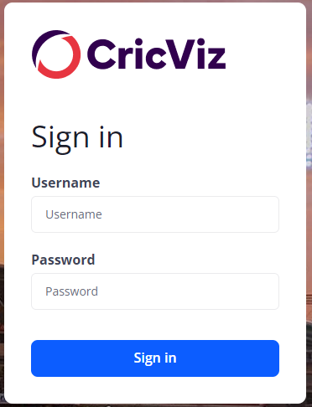

This is the login section for the program, and it only contains a username and a password label and input boxes. There is no option for a clear button which is not ideal as the user has to delete the fields in both input boxes if they realise their inputs are wrong. The sign in button will run the authentication when clicked.

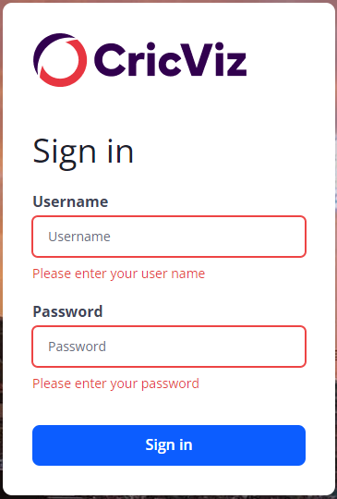

The input boxes are outlined in red when I click the sign in button without entering any input. I quite like this design, and I will use red as an error message colour in my program. The error messages appear underneath the input fields, but I think this is a bit cramped so I will include my error messages in a different place.

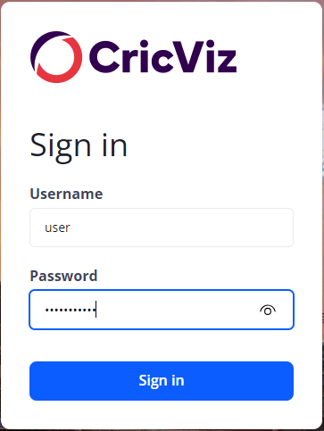

The password has a show password button. When the show password icon is clicked, the password is shown and then hidden when unchecked again.

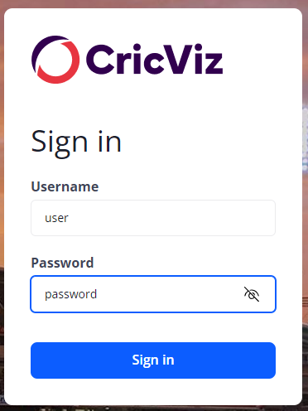

The icon changes when the show password icon checked. This is very visual and this makes it really easy to distinguish.

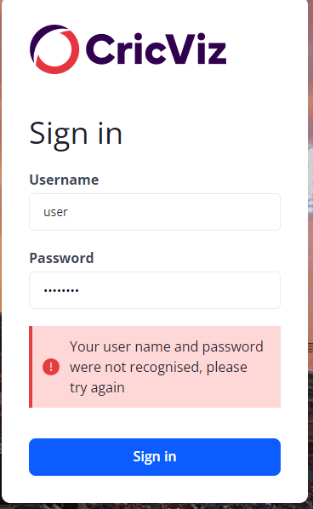

A different error message pops up if the server side function to check if the user is authenticated when the inputs are valid. I like this different error message for the client side and the server side validation and will include it in my program.

**CricViz advantages**

* Includes a vast amount of features to help analysts
* Is dynamic (win % changes as match progresses)
* Includes video ball tracking for pitch conditions analysis
* Large amounts of data visualisation
* Very accurate (used by cricket boards)
* Split into modules, and can easily navigate product
* Query tool and database included
* Show password button in login page, and different error labels for client and server side validation

**Disadvantages**

* Includes a vast amount of jargon, so stakeholders may not be able to understand
* Is locked behind a paywall
* Contains too many features for an average cricket fan, so they may be overwhelmed
* Could not find an option to drag and drop players from different teams to simulate their own matches
* Requires an install and specialist help
* No clear button on login page to clear fields.

**Fantasy Premier League**

The fantasy premier league (FPL) is a software that allows players to act like their own manager and buy different players with a set budget that they can put inside the squad. Points are scored based on how the players do in the real world, and their match rating is considered. While this is not exactly a cricket prediction software, it has some elements of prediction as well involved with the player picking, as different players have different prices depending on how well they have performed recently. Players can be transferred every week, and different managerial choices can be made which can boost points, such as making the best player captain and so forth.

Here I have included a snapshot of the FPL website. The website is very sleek and there is no unnecessary detail apart from the sponsorship logos. The pitch view is very nice to look at, with shirts being used as icons for each player and the position being displayed underneath. However, this is much harder to accomplish on a cricket predictor since there is no “formation” for the team and I would have to use something like the list view option on the FPL website.

The option to add players is very well written as it includes filters for the program to search for different players. In my program, I could do something similar by looking at the ICC ranking of each player. However, there is no option to filter by nationality which is something I would like to include in my program. This menu is very visual, but I don’t think I could replicate the shirts and different jerseys on my actual program given the time constraints I am under. The budget option is unnecessary with my program so I will not be adding it.

Here you can see the login page for the FPL website. It consists of a sign in label, with the input boxes to the right of the label. It consists of a sign in submit button, with an option to reset your password if you forget it. I will not be replicating this feature in my program, as this would require signing in with an email address/phone number such that the account can be recovered. This would require setting up networking/mail servers such that an option to reset the password is shown. I do not wish to implement the login with Google/x etc options as they would be too complicated to build in the given scenario. This would then require its own interface, and would require networking to access the SQL database. This would take too much time and would not increase the usability by a large factor. Hence, I will not be including this feature in my program due to its complexity and the time constraints I have on the program However, I do not like excessive advertising to use the product, as can be seen in the text to the left of the sign up button. Hence, on my login page, I will be using minimal text to make the interface as simple as possible.

This occurred after I typed in an incorrect username/password combination. I like this colour scheme as it is very visual and the alert box is very easy to read - I will aim to replicate something similar in my program as well.

This is input validation that seems to be done on the client side, as it displays a different error message to the previous one. This is a format check, and can be done on the client side to reduce the load on the server, and decrease waiting times for the server to provide a response. I can include a similar check in my program that will perform a presence check on both fields before sending a request to the central database.

This is the sign up page for creating a new account for the system. Since FPL is on a much larger scale than my program, it includes lots of information such as first name, last name and gender that can be excluded for my program. My program will only look at the username and the password, email address and confirm password.

When empty, an error message is displayed underneath the input box. The use of the cross icon makes this highly visual and I want to include something similar in my program as well.

The password must include checklist is very well done, as it shows which conditions are failing on the password, such that it can be distinguished if more than 1 condition fails, unlike a general password invalid error message.

Overall, I think the login/signup pages are very well done, and I will be taking a lot of features from these and will include them in my final program. However, I will scale this down for simplicity, and use a different aesthetic that will conform to the rest of my program.

By doing some research, I have also read about what type of variables and factors the FPL algorithm uses.

**Metric calculations**

FPL analytics use a wide range of performance metrics for players, such as goals scored, assists, clean sheets, and even subjective measures like influence, creativity, and threat (ICT) index. These metrics can be adapted to cricket, focusing on runs scored, wickets taken, catches, strike rates, and economy rates, among others.

FPL enthusiasts often use predictive models to choose players expected to perform well in upcoming matches, considering factors like form, fixtures difficulty, and historical performance against certain teams. For cricket, similar models can predict player performances based on opposition, venue, weather conditions, and recent form.

Managing a team within a budget and deciding when to transfer players in and out is a crucial part of FPL strategy. This aspect can translate into a cricket predictor program by considering player valuations and the impact of team changes on predicted outcomes - however, this is not a focus on my game as my stakeholders are not team managers/fully serious about the program and would just like to see some results and have fun. Hence, I will not be adapting my program to make it easier to make transfers/any managerial activity.

The FPL website also provides prior statistics on each player and a photo. Since I am not planning to update my program with each match in real time, I will not be including this feature and keep it more simplistic as adding this detail would not really help with the main purpose of the program.

**FPL Advantages**

* Very visual and easy to use
* Filters to drag and drop different players
* Free
* Updates in real time and is interactive
* Very concise (functionality covered in only 1 page)
* Login and signup page very visual and easy to interpret

**FPL Disadvantages**

* Have to sign in to use product.
* Advertisements and sponsorship logos seem clunky.
* Too much detail and statistics available to the user
* No option to simulate your own matches.
* Player selection restricted under a budget.
* Cannot sort players by nationality.

From this three software, there are a wide variety of features that I can include in my program

This will include:

* Simplified language to avoid jargon.
* Split into modules.
* Right number of extra features (not too simplistic, but not too complex)
* Theme changes depending on teams being simulated.
* Filters for adding new players to the team.
* Use cricket icons to make the software more aesthetic and visual.
* Restrict simulation to 1 format for ease of use and time constraints.

**The proposed solution**

My solution will consist of several parts to the program, which are developed independently to each other. The main features will be:

* Win prediction algorithm.
* Drag and drop different players to form an XI (players are filtered)
* Prediction of strongest possible XI before simulation on a new page
* Venue as input before simulation
* After simulation, scorecard available to download and also emailed to end user.
* Option to quit program or restart a different simulation after another has ended.
* Welcome page after login/signup explaining how to use the program.

Since I am using a computational approach, the solution is amenable to computational thinking strategies to streamline the development process.

For my project, I will consistently use Segoe UI as it is very clean and professional. In terms of images, I will require images such as stock player images, wickets, cricket balls, bats and more to make my program very visual and easy to use.

**Thinking ahead**

The program will use a quantitative approach to machine learning and will include factors such as date, time played, temperature, and will have a look at layer statistics. It will assess each player's record against the various factors and will weight each factor as required. The model will then finally predict by adding up each players score to finally build a team score as well. The bowling side will also be given a strike rate, average with match ups against each batsman modelled by bowler-batsman past records.

I will have multiple stages to my program, and it will be developed in modules. The inputs to my program will be done with a keyboard and mouse using text boxes that will provide suggestions for the desired player. Like this:

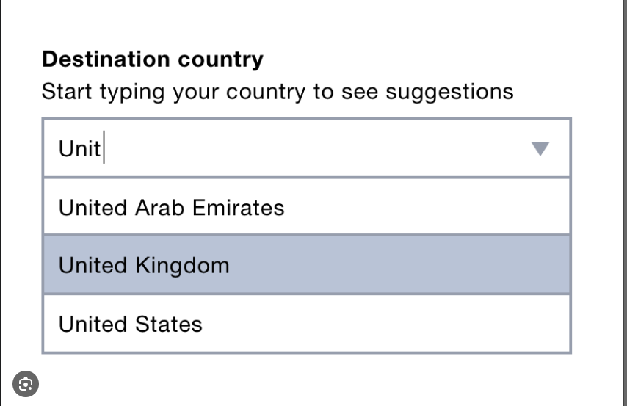

This is how the players, and the venue will be inputted.

The output screens for my program will include an original start up screen, where end users can choose between finding the strongest fantasy team or completing their own simulation. If they want to find the strongest fantasy team, the output screen will just be a list of the best players to pick, and an option will be given to quit the application or to restart. If they want to create their own simulation, the input screen will be shown with all the inputs. After the simulation has finished, the results screen will be shown, with an option to download/email the scorecard on another screen. The other option will be to quit or restart.

Hence, I will have to take the email address as an input to email the scorecard to the user. I will also be storing the most recent scorecard by a certain user in a file that can be accessed so that they can access their most recent simulation.

Another factor that I will have to investigate is the form of the logins database. If passwords are stored as plaintext, another user can sign in to a user’s account if they simply view the database. This is not very secure, so I will be implementing an encryption algorithm such that the passwords cannot be understood.

**Thinking procedurally**

My program will follow a structural cycle:

1. Login page
2. Welcome page that shows how to use program and menu to navigate to different pages.
3. Input page (for both simulation and predict best team)
4. Machine learning algorithm completes.
5. Results shown.
6. Results/scorecard available to download/email and view on a page.
7. Ending screen, which can either stop the application or loop back to stage 1/2 as desired if user decides to logout or restart program.

This means that the program will be developed in modules, and I can focus on each sub problem by decomposing the initial problem. Since I will be using similar functions for both my “strongest fantasy team” and “simulation” paths, I can reuse a lot of functions and algorithms using the computer, which allows for a computational solution to be built.

**Thinking logically**

I will have a lot of inputs that will include if statements, that can lead to different parts of the program. My start page input will lead to one of two branches depending on the input. For each of those, the inputs from the input pages will be used in if conditions inside the machine learning algorithm so it can contextualise the data provided by the inputs. An if condition will also be used to determine if they want the scorecard to be emailed, downloaded, both or neither after the simulation has finished. The last major if condition will be the end page, where the user can choose to restart the program or end the application. If the user decides to restart, there will be a loop that will go through the program such that it begins from the start again.

**Thinking concurrently**

Since the machine learning algorithm may take some time to display the results, there is an opportunity to use concurrency in my program. Whilst the machine learning algorithm is running, I can start to display the GUI for my program already and load all the extra libraries and modules that will be used for the analysis later. This will mean that the user must wait for less time and will lead to a more seamless user experience.

**Limitations**

Some of the features from the programs that I have looked at will be impossible to develop and replicate effectively in the given time. For example, a possible fantasy game like the Fantasy Premier League for football has too many features, and the code and databases need to be updated regularly, and new data needs to be received after a match has been played. This would be too difficult to accomplish in the period that we have for this period, and hence I will not be including it in my program. Another limitation to my program is the use of rolling data in my simulations. This would mean that the data would have to be regularly updated after each new match, which would involve a lot of API calls and networking. I think this would be too difficult to learn and apply before the deadline, and hence I will only use 1 set of the most recent data, and possibly update the dataset and retrain the model after a certain time, maybe around every 3-6 months. Since I am using WinForms for my project, resizing will be an issue and hence I will be making the size of the form a fixed size, but that size will also mean that it should be visible on all display screens. Hence, it may appear to be different sizes on a QHD monitor compared to a FHD monitor, but all features should be able to be accessed regardless. This will mean that I must restrict the form so that it cannot be resized.

## (iv) SPECIFIY THE PROPOSED SOLUTION

*(a) Specify and justify the solution requirements including hardware and software configuration (if appropriate).*

*(b) Identify and justify measurable success criteria for the proposed solution.*

Success Criteria

Aesthetic Objectives:

* a. The window will be 1100px by 600px and will not be resizable.
* The background colour will be blue for all screens.
* b. A blue, black and white colour scheme will be used in accordance with stakeholder requirements.
* c. The font used throughout will be Segoe UI, and the size will be consistent with the size of the text boxes. Occasionally, another similar font may be used. Player names will be small while titles will be large comparatively.
* d. The background colour for text boxes is white, and the text inside buttons will be black.
* e. Input boxes will be white, with placeholder and inputted text being black.
* f. The title of the page will be at the top for each page, and there will be a footer at the bottom for each page.
* g. Error labels should be to the right of the relevant input box, and they should be the same size font as the labels/input boxes, but should be red in colour, and invisible if there is no error.
* g. Welcome page
  + The menu page will have 2 buttons near the top to navigate to the “predict best fantasy team” (PBFT) or the simulation page.
  + There will be a button near the top right-hand corner of the page to exit the application, which will be the same for all pages.
  + There will be an option to download the most recent scorecard simulated by the account, that can be accessed by clicking a button towards the right of the screen.
  + The title will be blue and will display “Menu”.
  + There will be a logout near the top left corner of the screen that will return.
* h. Signup page
  + There will be 4 input boxes with the order being email address text, username, password and confirm password to ensure that the user does not misinput into the password field.
  + The input boxes will be vertical arranged and aligned. For each input box, there will be a label to the left to indicate it’s a username, password etc.
  + For each input box there will also be an invisible error label to the right, that will display the relevant error message in red.
  + The username input will contain placeholder text that displays sriv123 and this will also be true for the email address, with placeholder text being [sri@gmail.com](mailto:sri@gmail.com) (not real email).
  + There will be button underneath the input boxes which is the sign up button. When clicked, if the inputs are valid (username/email not already in database etc), it will create a record in the database with a username and a password. Then, the user will be on the main menu with the account they just created. When it is clicked all error messages should be cleared
  + If the inputs are incorrect, a relevant message will be displayed in the error labels to indicate which error has occurred and in which field the errors have occurred.
  + There will also be a button next to the register button, that will act as a clear button. This will clear the values of all fields.
  + There should be a show password checkbox underneath the confirm password input box that will show the password when checked and hide when unchecked. The password is set to hide as default. This should automatically be unchecked when the clear button is clicked.
  + This page should be accessible if the user decides to logout.
* i. Login page
  + There will be 2 input boxes with the order being username and password.
  + The input boxes will be vertically arranged and aligned. For each input box, there will be a label to the left to indicate it’s a username/password.
  + For each input box, there will be an invisible error label to the right, that will display the relevant error message.
  + The username input will display placeholder text.
  + There will be a button underneath the inputs, which will give an option to register, and this will be highlighted when hovered over. When clicked, if inputs are valid, it will login into the main menu on the user’s account.
  + There will be button underneath the input boxes which is the login button. When clicked, if the inputs are valid (username/email not already in database etc), it will check against the records in the database to match the user to an account. Then, the user will be on the main menu with the account they just logged in with. When it is clicked all error messages should be cleared
  + If the inputs are incorrect, a relevant error message should be displayed in the error labels to indicate which error has occurred and in which field the errors have occurred.
  + There will also be a button next to the register button, that will act as a clear button. This will clear the values of all fields.
  + There should be a show password checkbox underneath the password input box that will show the password when checked and hide when unchecked. The password is set to hide as default. This should automatically be unchecked when the clear button is clicked.
  + This page should be accessible if the user decides to logout.
* i. Simulation page
  + The title will be blue and will display “Simulation”, and the page will be split into half down the middle of the page.
  + It will contain 11 text boxes to input players.
  + Player input boxes will have an icon with the respective position e.g. a wicketkeeper may have a pair of gloves next to it.
  + Player input boxes will contain a filter for nationality, ICC ranking that will use similar buttons/input boxes to control .
  + Each input box will select a player and their name will pop up in the input box after they have been selected. With the input box, there will be an option to also remove the current player.
  + Duplicate players must not be added, so that no player can be repeated in the 22 players.
  + There will be a button at the bottom of the input boxes that will confirm a submission.
  + When both submissions are confirmed, the simulation will start, and the scores of both teams will be outputted, and the individual scorecard will be omitted.
  + Another button below the scores will give an option to reset the current simulation and remove all selected players from their slots.
  + The scorecard can be accessed from the main menu through the button as previously mentioned.
  + Once again, buttons to the menu page and PBFT will be at the top of the page near the title.
  + There will be a final smaller menu inbuilt into the simulation page where users can alter the pitch conditions, toss etc.
* j. PBFT page
  + The title will be blue and display “Best fantasy team” and it will be at the top of the page.
  + There will be a button in the centre of the page that will initialise the prediction.
  + There will also be 11 empty player slots on the screen, with icons to show the role of each player.
  + Once the algorithm is finished, the names of the players will be assigned next to their respective icons.
  + Lastly, there will be a button towards the bottom that will restart the algorithm.

Inputs:

* a. Screens are navigated through buttons on the screens, and a navigation menu near the top, and some functionality is also controlled by these buttons as well.
* b. Text entry fields:
  + Simulation – Add each player to a slot by typing in their name and will provide a drop-down menu as discussed earlier. This input is a name that will be validated and cleansed to ensure that no erroneous data is inputted.
* c. Non navigation buttons
  + Used to control confirmation of a submission/scorecard/start simulation as well as swap the current player/remove/restart simulation in the Simulation page.
  + PBFT page used to reset/start prediction.
* d. Username and password will be inputted into the login page, checked against the database and will enter the program/fail depending on the inputs
* e. Username and password will also be inputted into the sign-up page. The username and email will be checked against the database to make sure it is not already in the database or empty, and the password will have a minimum of 8 characters and 1 number and 1 special character. The password characters should appear as *** when typing in password and confirm password. Password and confirm password should match for signup to be successful.
* f. In the signup page, email address will also be inputted. A format check is required such that it is in the form [sri@gmail.com](mailto:sri@gmail.com), with the @ and the domain. This will be used to mail the scorecard to the email address, and hence will also require for the email to be existent.

Processing:

* a. There are two main functions being used in the program – the PBFT function and the simulation algorithm. Either of these will need to be used depending on the page they are in.
* b. Simulation
  + The simulation algorithm will be run, using the 22 selected players and the conditions as the arguments and will return the scores and the resultant scorecard.
  + The input validation will be done outside of the function.
* c. PBFT
  + The simulation algorithm will run, and the only parameters will be the pitch conditions, venue etc – 11 players with different roles will be returned

Hardware/Software requirements:

* Must have a 4-core processor and above that can run Windows
* Must be connected to the internet.
* Must have a suitable web browser – Chrome, Safari etc.
* Must have a mouse/touchpad/keyboard for inputs.
* Must be able to run Python, SQL, .NET and sklearn, TensorFlow, pytorch, pandas must be pre-installed into the Python interpreter.
* Must have more than or equal to 4GB of RAM.
* Must be able to run SQL/SQLite

You must have detail here, because this will form a substantial part of your evaluation and is also your success criteria. If you just say “I will create a game”, then your evaluation will be “I created a game”!. You will also need to list the hardware and software requirements. This will include stations (laptops/PC.Tablets etc), the OS, any software needed (e.g. Python), any peripherals (printers etc) and networking.

**Here is an example of solution requirements:**

Following this feedback, I have made some changes to the design objectives. The new objectives can be seen below. The altered parts have been highlighted.

1. Aesthetic objectives
   1. The window size is 800x600 pixels and the window should be non-resizable
   2. The colour scheme is a light blue background with white and yellow text
   3. The monster character will be a dark blue/purple colour with a hair-like texture
   4. Text boxes where text must be entered will be filled white rectangles
   5. Text in text boxes will be black
   6. The font used will be Arial Rounded MT Bold or similar and will be consistent throughout the software
   7. Action buttons
      1. These have yellow text in all capitals
      2. They have square corners
      3. They will have a slight raised effect
   8. Quick Fire Questions
      1. The questions appear one at a time
      2. The questions are white and in large writing
      3. The answer is entered in a text box at the bottom of the screen
      4. Right answer – ‘Correct!’ is displayed on the screen in green writing
      5. Wrong answer – ‘Incorrect!’ is displayed on the screen in red writing
2. Inputs
   1. Screens are navigated and actions are carried out by clicking on-screen buttons
   2. There are text entry fields on the following screens:
      1. Student Log In
         1. Information to be entered - username
      2. Teacher Log In
         1. Information to be entered - password
      3. Add Student
         1. Information to be entered – first name and last name
      4. Delete Student
         1. Information to be entered – student username
      5. View Students
         1. Information to be entered – student username
      6. Game Screen
         1. Information to be entered – answer
   3. Check boxes are used to select times tables
3. Processing
   1. The software will need to change the questions used in the game depending on the times tables selected
   2. Quick Fire Questions
      1. Random questions will be generated
      2. The software needs to determine whether the given answer is correct
      3. The software needs to record the number of correct answers given
      4. A timer is used to time how long it takes for 20 correct answers to be given
   3. The software will need to update the high scores if necessary at the end of the game
4. Outputs
   1. Quick Fire Questions
      1. The question is displayed
      2. The number of correct answers out of 20 is displayed
      3. The timer is displayed
      4. Whether an answer was right or wrong is displayed
      5. The final score is shown at the end of the game
   2. High Scores
      1. Displays top 5 times for the game
   3. View Students
      1. Displays list of all student usernames on screen
      2. Must be able to display at least 45 students
      3. If a username is entered, a pop up appears with that user’s details
   4. Pop ups are used to alert the user if a wrong username has been entered, or if a field has been left empty
      1. These should have a design consistent to the main program window

# (2) Design OF THE SOLUTION [15 marks]

## (i) DECOMPOSE THE PROBLEM

*(a) Break down the problem into smaller parts suitable for computational solutions justifying any decisions made.*

**Python**

For the actual machine learning algorithm itself, I will use Python as it is the industry standard when it comes to data analytics/deep learning. This means that it is very well suited to the work I will be doing. Another reason for choosing Python is that many tutorials to learn how to create the ML algorithm are done in Python, as it is the industry standard. This will make learning the skills to create the program easier to accomplish. Python also contains lots of libraries for this purpose, so I can reuse lots of code in my program, which will save time and be more efficient for the end user. The libraries used in Python make file handling rather simple and have inbuilt integration with database software such as SQL and SQLite.

**GitHub**

Another feature I will be using is that I will maintain my project in the cloud using Git. I will create a local repository which can be then pushed onto the cloud and then changes can be staged, committed, pulled/pushed to keep different versions of the project the same. The use of this version control would also allow me to access and change the project from different local machines, which would mean that I could edit my project from various places, such as from school and from home, without having to worry about saving it in a cloud/emailing as it will be controlled, and any errors will be managed by the software itself. I am choosing Git as my source control as it is widely used in industry, and there is direct support built into the IDE that I am using – VSCode for Python and Visual Studio for .NET. There are extensions for Git in VSCode and Visual Studio that provide autocomplete features as well as more functionality which I can use to make programming more productive.

**.NET Core with C#**

I will also be using the .NET core to build my application and provide a GUI directly on Windows, which will run on C# using WinForms. I am using .NET to build my application as it is very commonly used in industry. It contains features which are directly supported by Windows, making designing buttons/other parts simple. This is because buttons are built as modules, so they can be redesigned very easily and reused very simply compared to coding a button from the start itself. .NET Core is ideal because it keeps user data safe and also has a strong community of developers and lots of guides and help available. This makes building the app easier because you can find solutions quickly and reuse working code that other people have built previously. It is a RAD (rapid application process) so it is very easy and quick to develop applications

**SQL Database and csv files**

I will be using a SQL database to store temporary data in calculations and the user accounts information. I will be using SQLite to accomplish this as it is very easy to set up and start working with compared to a full SQL server, which adds more complexities to the problem and is not necessary for this scenario. The advantage of using SQL is that it is specifically made as a database management system, and the searching and sorting algorithms are very fast compared to Excel. Complex queries can also easily be carried out in code which also makes them much more suited for this program. SQL servers are also used to maintain ACID – as they apply features such as record locking to ensure that ACID principles are maintained throughout for a consistent database with integrity. I will meanwhile be storing my historical data as csv files as pandas (the python module for machine learning has large amounts of functionality built for csv files, so the data analysis will be very easy to accomplish. It is also the industry standard when it comes to these types of programs.

Choose and justify your choice of language – it is NOT good enough to say I will use Python cause school have it and I can use it. That can be mentioned, but you should say – I will use python because it has libraries that I can utilise, such as….I am not too concerned about the GUI element of my solution…..The file handling in Python is relatively easy…..I can adapt Python to become an OOP and this will help me because – this class will contain this object and this object and this object, reducing the amount of code that I need. I will use python in a procedural manner because my project will achieve this task and then this task and so on which lends itself to the procedural nature of this language.

Include a top-down diagram (or inheritance/class diagrams for OOPS) to describe your project and how it will interact. You could include other DFDs – including Entity diagrams Activity diagram, use case. You will include flow diagrams for your work. But I would recommend in

e.g. 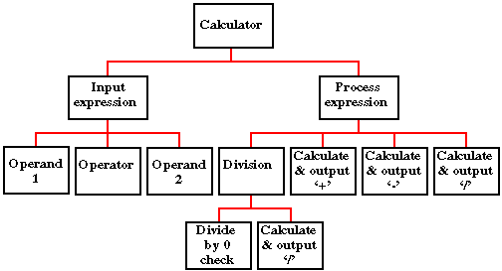

Top down diagrams are used for procedural programming languages.

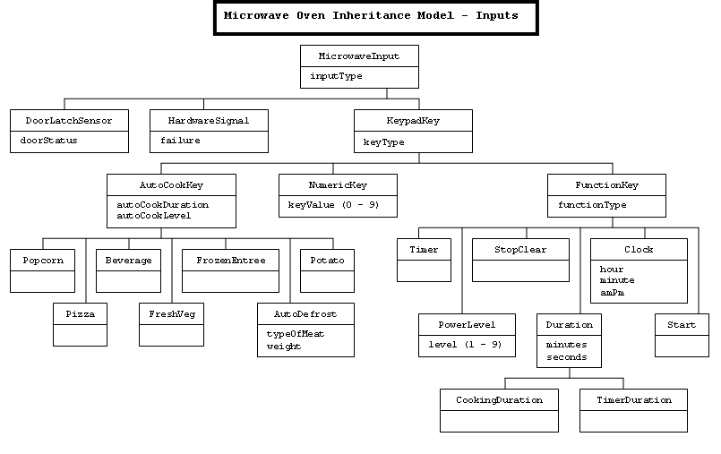

Class/Inheritance diagrams are for object orientated code, you do not need to do this if you are using a procedural language

Try and reduce this diagram to it’s smallest component parts.

You may wish to reference some of the computational think in this section by refereeing to:

* Abstraction – what have you discarded?
* Thinking ahead – what problems/limitations can you foresee?
* Thinking concurrently – quickly dismiss any thought of using cores independently
* Reference the next section to thinking procedurally

**THIS STRUCTURE DIAGRAM NEEDS TO BE CHANGED**

**Immediate issues and abstracted features**

There are a couple of features that I have abstracted from this structure diagram. I have not included any input validation as it will all be contained inside the various functions and subprograms, such as the login and signup page. The main machine learning algorithm is contained inside the different pages for the program and will execute only on that page. I also have discarded all the aesthetic objectives since they are not relevant in the structure diagram.

Some of the immediate issues I can see is the database storage. If this will be done centrally, this will require lots of networking and cloud storage may have to be used. This essentially creates another problem in the structure diagram, so I may decide to not include cloud database storage depending on the development process. There are some other features that I may decide to change during the development process as well.

It will be hard to use cores independently as each screen in the program is self-contained, and hence cannot be worked on while other screens are running. This only leaves the main machine learning algorithm to run alongside the visual outputs, and the visual outputs do not require much computing power and hence concurrent processing will not be used in the program.

## (ii) DESCRIBE THE SOLUTION

*(a) Explain and justify the structure of the solution.*

*(b) Describe the parts of the solution using algorithms justifying how these algorithms form a complete solution to the problem.*

*(c) Describe usability features to be included in the solution.*

*(d) Identify key variables / data structures / classes justifying choices and any necessary validation.*

*(e) Identified and justified the test data to be used during the iterative development of the solution.*

Explain any connections, dependencies or links between parts of you design e.g. the main page will have a login drawing on data from users table.

Modularise you work e.g. complete these elements for each of your modules (screens)

Using the example above – the calculator

**Calculator – Main Page**

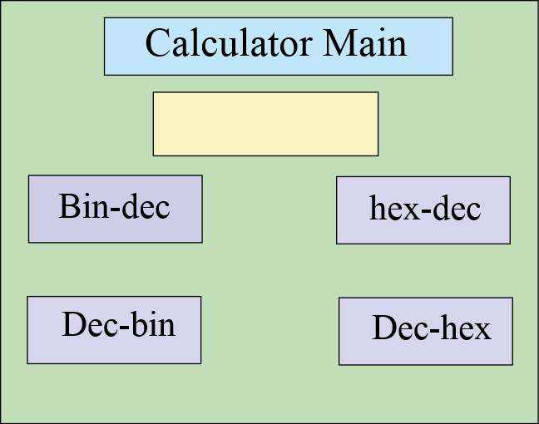

The main page will contain the options for my binary calculator. I will have four options that the user is allowed to choose (bin-den, den-bin, hex-den, den-hex) and they can enter the number onto the front page. It will also store their number in a file for later use. There is a title, data entry for number buttons……

Remember to list all of the variable/functions used, their purpose, data types and validtions

**Functions and variable used:**

Var click_me Boolean 0 or 1 validation – lookup check 0 or 1

Var sci_bin String (3) – validation – length check (3 chars)

Func_conv_bd(number) function that converts binary numbers to denary numbers

**Flow chart to show the process**

START

Bin to den?

Den to bin?

Remember to include routines for the validations

*……………………….etc*

**Pseudo code**

Proc calculator_main

Open main_page

If x < 7

Open random_message(“this must be a binary number”

End if

………………………………….etc

In order to test the functionality of this page, I will test the following items

**Button1**

Should close the main page and open the denary – binary converter

**Button 2**

Should close the main page and open the binary – denary converter

………………………etc

You need to plan the tests that you will use as you are developing this module – it can be quite short – tests should be designed to demonstrate that your system is working – particularly validations and the logic of the module.

**Test Plan for development**

**For var_number**

|  |  |  |  |  |
| --- | --- | --- | --- | --- |
| Test data | Test type | Predicted outcome | Actual outcome | Pass/Fail |
| 010100101 | valid | Saves number |  |  |
| 01010100101001010100 | borderline | Saves number |  |  |
| 000000000000 | boarderline | Saves number |  |  |
| bob | Invalid | Rejects text |  |  |

………..etc

**Login Page**

This is the design for the login page of my program, and I have included a title at the top to display that this is the login page as well as a footer if any additional information needs to be displayed. The page consists of a consistent screen design that will be the same across all screens using the appropriate colour scheme that my stakeholders desire. The main items include the text boxes that will display relevant placeholder text to ensure that my users know what to do when using the program. These have labels to the left indicating which input box they are, and error labels to the right indicating which error has occurred. These labels only show the client-side validation while the server side authentication will be shown at the top in an error bar. There will be a show password checkbox to show the password because it will appear as ***. The clear button should clear all input fields and uncheck the show password checkbox. Finally, the login button should cause the authentication to run.

**Variables used:**

* **var username**: String. Captures the user's input for the username. Required to be between 1 and 15 characters to prevent input boxes from being too full.
* **var password**: String. Captures the user's input for the password. Required to be between 1 and 15 characters to prevent input boxes from being too full.

All of the fields will be trimmed beforehand and stored, which will remove leading and trailing spaces.

**Function ValidateInputs(username, password), returns Bool**

* Checks that the username is not empty and within the 1-15 length range. Displays the relevant error message in the adjacent error label.
* Checks that the password is empty and within the 1-15 length range. Displays the relevant error message in the adjacent error label.

**Function AuthenticateUser(username, password) returns Bool**

* Only runs if ValidateInputs is true.
* Creates and executes a SQL query that gets the number of records in the logins database useraccounts table with the specified username and password. The password is encrypted and then compared to the encrypted passwords in the database.
* If the SQL query returns 0, then return false and display username and password combination incorrect error message.
* If the SQL query returns a value larger than 0, then return true and proceed to the simulation page of the program.

**Procedure ClearButtonClicked**

* Executes when clear button is clicked.
* Clears values inside input boxes and error label.
* Unchecks show password checkbox such that password appears as *

**Procedure ShowPasswordCheckboxChanged**

* Executes when the show password is checked/unchecked.
* This will hide the password as * if the checkbox is unchecked and will show the password if the checkbox is checked.

**Procedure LoginButtonClicked**

* This should run the functions ValidateInputs and RegisterNewUser and should be disabled after being clicked once in a cycle.

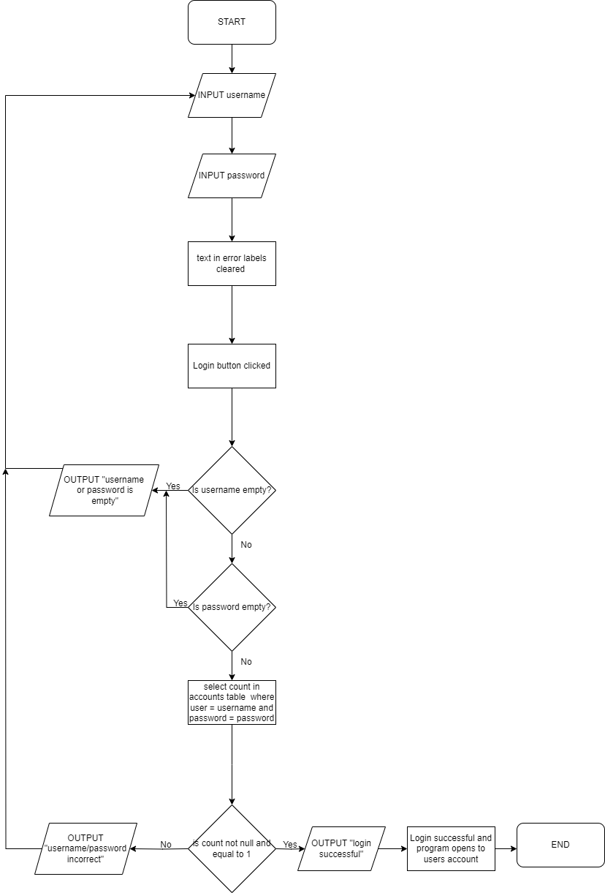

**Flowchart**

**Pseudocode**

**Client side**

Function ValidateInputs() Returns Boolean

isValid = True

If UserName is empty

Set UserName error label to "Username is required"

isValid = False

If Password is empty

Set Password error label to “Password is required”

isValid = False

Return isValid

**Server side**

Function AuthenticateUser(username, password) Returns Boolean

Connect to database

Define query for user authentication using USERNAME=username and PASSWORD=encrypted password

Execute query and store the result

If result is 1

Return True

Return False

Testing plan

**Username text input** - this should store the inputted value inside the variable username and should lie within the allowed data values. Placeholder text should be removed as typing starts.

**Password text input** - this should store the inputted value inside the variable password and should lie within the allowed data values. There will be no placeholder text.

**Procedure LoginButtonClicked** – this should run the ValidateInput and AuthenticateUser functions. It should be disabled after being clicked once in a cycle

**Procedure ClearButtonClicked**

* Executes when clear button is clicked
* Clears values inside input boxes and error label
* Unchecks show password checkbox such that password appears as *

**Procedure ShowPasswordCheckboxChanged**

* Executes when the show password is checked/unchecked
* This will hide the password as * if the checkbox is unchecked and will show the password if the checkbox is checked

**ValidateInputs**

Username

|  |  |  |  |  |
| --- | --- | --- | --- | --- |
| Test data | Test type | Predicted outcome | Actual outcome | Pass/Fail |
| “user” | valid | Error message not visible |  |  |
| “” | invalid | Displays empty error message |  |  |
| “ “ | invalid | Displays empty error message |  |  |
| “a” | borderline | Error message not visible |  |  |
| “username user21” | borderline | Error message not visible |  |  |
| “usernameusernam” | invalid | Should not be able to type into input box |  |  |
| “ user program ” | valid | Error message not visible |  |  |

Password

|  |  |  |  |  |
| --- | --- | --- | --- | --- |
| Test data | Test type | Predicted outcome | Actual outcome | Pass/Fail |
| “user” | valid | Error message not visible |  |  |
| “” | invalid | Displays empty error message |  |  |
| “ “ | invalid | Displays empty error message |  |  |
| “a” | borderline | Error message not visible |  |  |
| “username user21” | borderline | Error message not visible |  |  |
| “usernameusernam” | invalid | Should not be able to type into input box |  |  |
| “ user program ” | valid | Error message not visible |  |  |

The validations for password and username on the client side for the input box itself are the same so I have included the same test cases for both username and password input boxes.

**func AuthenticateUser**

Assuming we have [[“user1”, “password1’], [“user2”, “password2”]] as our password username pair in a logins database, we can construct a test plan that will test certain username password pairs.

|  |  |  |  |  |
| --- | --- | --- | --- | --- |
| Test data | Test type | Predicted outcome | Actual outcome | Pass/Fail |
| “user1”, “password1” | valid | Error messages not visible |  |  |
| “user1”, “password2” | invalid | Displays not authenticated error message |  |  |
| “user2”, “password2” | valid | Error messages not visible |  |  |
| “user1”, “user1” | Invalid | Displays not authenticated error message |  |  |
| “user14”, “password1” | invalid | Displays not authenticated error message |  |  |

**Register**

The main idea of the register page remains the same as the email in the fact that the colour scheme, input boxes and error labels remain the same. However, for the registration page, there will be no error bar and each error will be displayed in the relevant error label because it is easier to detect in which field the error has occurred in. There are additional input boxes to store the email and confirm password to ensure the user will not mistype a password. The register button will register the user into the database provided that the username and email are not already in the database. The show password checkbox will just show the password when checked and will hide the password as * otherwise. The clear button will remove all inputs from the input boxes and uncheck the show password checkbox.

**Variables Used**

* **var username**: String. Captures the user's input for the username. Required to be between 1 and 15 characters to prevent input boxes from being too full.
* **var password**: String. Captures the user's input for the password. Required to be between 1 and 15 characters to prevent input boxes from being too full.
* **var emailAddress**: String. Captures the user's input for the email address, validated against a standard email format, max length is 30.
* **var confirmPassword**: String. Captures the user's input for confirming the password, compared with the password variable for equality.

All the fields will be trimmed beforehand and stored, which will remove leading and trailing spaces.

**Functions and Logic Used**

**func ValidateInputs() returns Bool**

* **Username Validation**: Ensures the username is non-empty and within the 1–15-character range. Displays an adjacent error message for invalid inputs.
* **Email Address Validation**:
  + Verifies non-emptiness of the email address.
  + Uses regex ("^[^@\s]+@[^@\s]+\.[^@\s]+$") to validate the email format, displaying an error for mismatches. Regex taken from https://emaillistvalidation.com/blog/email-validation-in-javascript-using-regular-expressions-the-ultimate-guide/.
* **Password Validation**:
  + Confirms the password's non-emptiness and adherence to the 8–15-character range.
  + Applies regex (@"^(?=.*\d)(?=.*[!@#$%^&*])(?=.*[a-zA-Z]).{8,15}$") to ensure it contains at least 8 characters, 1 number, and 1 special character, indicating invalidity through an error message otherwise. This regex has been taken from <https://stackoverflow.com/questions/19605150/regex-for-password-must-contain-at-least-eight-characters-at-least-one-number-a> and adapted to meet requirements.
* **Confirm Password Validation**: Checks for a match with the password, indicating discrepancies through an error message.

**Procedure RegisterNewUser(server_successful, client_successful)**

* Checks if username/email used with registration is already in logins database.
* If so, relevant error message will be displayed.
* Otherwise, it will add username, email address and password as a record to the database.

**Procedure ClearButtonClicked**

* Executes when clear button is clicked.
* Clears values inside input boxes and error label.
* Unchecks show password checkbox such that password appears as *

**Procedure ShowPasswordCheckboxChanged**

* Executes when the show password is checked/unchecked.
* This will hide the password as * if the checkbox is unchecked and will show the password if the checkbox is checked.

**Procedure RegisterButtonClicked**

* This should run the functions ValidateInputs and IsSignUp, and should be disabled after being clicked once in a cycle.

Flowchart

Pseudocode

**Client side**

Function ValidateInputs() Returns Boolean

Set allValid to True

Reset error labels for UserName, Password, EmailAddress, and ConfirmPassword to empty

If UserName input is not valid

Set UserName error label to "Username is required"

Set allValid to False

If EmailAddress input is not valid

Set EmailAddress error label to "Email address is required"

Set allValid to False

Else

Define pattern for valid email

If EmailAddress does not match the pattern

Set EmailAddress error label to "Invalid email address"

Set allValid to False

If Password input is not valid

Set Password error label to "Password is required"

Set allValid to False

Else

Define pattern for strong password

If Password does not match the pattern

Set Password error label to "Password too weak"

Set allValid to False

If Password does not match ConfirmPassword

Set ConfirmPassword error label to "Password does not match"

Set allValid to False

Return allValid

Function IsValidInput(input) Returns Boolean

If input is null or empty

Return False

Return input is not just whitespace

**Server side**

Function RegisterNewUser(username, password, email) Returns Boolean

Open connection to database

Define query to check existence of USERNAME or EMAIL

Execute query and store the result

If username/email already in database`

Set username/email error label to username/email unavailable

Return false

else

Define query to insert new user with username, encrypted password, and email

Execute insertion query

Output Registration successful message

Return true

A combination of these functions will be used to build the final solution for registration. Once RegisterNewUser has returned true, the program will proceed to the simulation page.

Test plan.

**Username text input** - this should store the inputted value inside the variable username and should lie within the allowed data values. Placeholder text should be removed as typing starts.

**Password text input** - this should store the inputted value inside the variable password and should lie within the allowed data values. Placeholder text should be removed as typing starts and will contain the strength requirements for the password.

**Email text input** - this should store the inputted value inside the variable email and should lie within the allowed data values. Placeholder text should be removed as typing starts.

**Confirm password text input** – this should store the u=inpuuted value inside confirmPassword and will have not have as much input validation as the only validation is checking whether it equals password. There will be no placeholder text.

**Button Signup** - this should run the ValidateInputs function using username and password as parameters, and the output of this function will run the IsSignup function. It should be disabled in a cycle if it has been clicked once already.

**Button Clear** – this should clear all input fields and uncheck the show password checkbox to hide the password again.

**Show password checkbox** – this should show the password when checked and hide when unchecked.

The last 2 functions should not need a test plan because this can immediately be verified without a test plan, and creating a test plan would not be an efficient use of time in project.

ValidateInputs()

Username

|  |  |  |  |  |
| --- | --- | --- | --- | --- |
| Test data | Test type | Predicted outcome | Actual outcome | Pass/Fail |
| “user” | valid | Error message not visible |  |  |
| “” | invalid | Displays empty error message |  |  |
| “ “ | invalid | Displays empty error message |  |  |
| “a” | borderline | Error message not visible |  |  |
| “username user21” | borderline | Error message not visible |  |  |
| “usernameusernam” | invalid | Should not be able to type into input box |  |  |
| “ user program ” | valid | Error message not visible |  |  |

Password

|  |  |  |  |  |
| --- | --- | --- | --- | --- |
| Test data | Test type | Predicted outcome | Actual outcome | Pass/Fail |
| “pass” | invalid | Displays weak password error message |  |  |
| “” | invalid | Displays empty error message |  |  |
| “ “ | invalid | Displays empty error message |  |  |
| “password123” | invalid | Displays weak password error message |  |  |
| “password@1” | invalid | Displays weak password error message |  |  |
| “passwo1@” | borderline | Error message not visible |  |  |
| “password123456@” | borderline | Error message not visible |  |  |
| “password123456@1” | invalid | Should not be able to type into input box |  |  |
| “pass123@” | invalid | Displays weak password error message |  |  |

Email

|  |  |  |  |  |
| --- | --- | --- | --- | --- |
| Test data | Test type | Predicted outcome | Actual outcome | Pass/Fail |
| “bob” | invalid | Displays wrong format error message |  |  |
| “” | invalid | Displays empty error message |  |  |
| “ “ | invalid | Displays empty error message |  |  |
| “sri@gmail” | Invalid | Displays wrong format error message |  |  |
| “srigmail.com” | invalid | Displays wrong format error message |  |  |
| “ben@gmail.com$” | invalid | Displays wrong format error message |  |  |
| “sri@gmail.com” | valid | Error message not visible |  |  |
| “sri123@patesgs.org” | valid | Error message not visible |  |  |

Confirm password.

Confirm password is very simple to test, and only requires 2 test cases, one that matches the password and one that doesn’t. If it doesn’t match, the error message “mismatch” should be displayed. Otherwise, no error message is displayed.

func RegisterNewUser

Assuming we have [[“user1”, “password1@”, “user1@gmail.com”], [“user2”, “password2@”, “user2@gmail.com”]] as our records in a logins database, we can construct a test plan that will test certain username password pairs. All of these assume that password and username are valid, since these will be server-side functions.

|  |  |  |  |  |
| --- | --- | --- | --- | --- |
| Test data | Test type | Predicted outcome | Actual outcome | Pass/Fail |
| “user1”, “password123, “user1@gmail.com” | invalid | Displays duplicate username and email error message |  |  |
| “user2”, “password22@”, “user3@gmail.com” | invalid | Displays duplicate username error message only |  |  |
| “user3”, “password2@”, “user2@gmail.com” | invalid | Displays duplicate email error message only |  |  |
| “user4”, “pass2345@”, “user4@gmail.com” | valid | Returns true |  |  |

**Simulation page**

**Design model**

**Machine learning model**

The machine learning model will aim to look at data from the ball-by-ball data for international matches, and I am only including data post 2017 to keep the data relevant. I will require 2 models, one to predict the number of runs scored on a certain delivery and the other will predict if a wicket is taken or not. For a machine learning model, there are a set number of steps required to create a fairly accurate model:

* Load the dataset as a dataframe using python’s pandas library.
* Add any additional features to make the model capture nuances in the dataset – this is known as feature engineering.
* I will then need to specify the features – these are the values that the model will use to build patterns and find those patterns inside the data.
* I will then need to specify my target variable, which is what I am going to predict. In this case, it would be the runs scored on the ball and if a wicket is taken on that ball.
* I will then need to transform the data and encode the categorical values – these are values that are not numerical but strings or other data types. Machine learning only considers numerical values so I must encode them, and then transform the dataframe to match the encoded values.
* I would then need to split the data into training and test data, often 80% of the data is used to train and 20% is used for testing.
* I will then need to initialise the model and then fit it to the data.
* I will then need to have a look at the performance of the model. These metrics may depend on which model I will choose to use for my project, but common metrics include mean squared error, r squared error and accuracy.

**Flowchart**

**Iterative adjustments**

Of course, this all depends on the model being used, and I may choose to adjust my model if it has a low performance. There are various ways in which I can change my model, which include changing the entire model itself, or changing the hyperparameters of the model. Hyperparameters are the configuration settings used to structure the learning algorithm, and this includes factors such as the learning rate, which is how fast a model will train. I can adjust these hyperparameters and can use the ones which give me the best performance. A way I can do this is by using gridsearch. Gridsearch is a method where a list of hyperparameters is used – a parameter grid. The model then loops through testing using each of these hyperparameters and the combination of hyperparameters with the best performance are used.

**Code optimisation**

This model will then be used to predict the outcome of a particular ball, given various input features such as the bowler, striker, non-striker, phase and venue. Once I am happy with the trained model, I will save it and load it when it is required, and this saves a lot of time as training a model is time exhaustive. After doing some research, I found that python’s joblib model can be used to save models and load them into the program when necessary.

**Fallback on general statistics**

However, there is an issue with this type of machine learning model. Since it is not a simple regression model and requires randomness, overfitting can easily occur when data is sparse. For example, if there is only 1 record between a particular batsman and a bowler, and it happens to be a 6, the model would predict a 6 every time with that specific striker bowler combination, which is unrealistic.

Hence, when data is sparse, I will need to fall back onto general statistics, and not look at the specific player to player records. Hence, for this I will need another file that will incorporate these statistics. For example, I can take the runs scored per ball for a batsman by summing the total runs scored over the total number of balls faced. I can these use this value inside a Poisson distribution, or a similar random distribution get a good estimate for the number of runs. This implementation would be much more advanced in the real program and would require experimentation with values to ensure that I get sensible probabilities for each outcome, while also ensuring that there is a chance of a 4/6.

**Pseudocode for runs model when data is sparse**

FUNCTION simulate_sparse_runs(striker, bowler)

Load database as dataframe

Filter database using striker and store inside striker_df

Count number of each outcome in striker_df

Divide each by total number of records to calculate probabilities

Normalise so probabilities sum to 1

Filter database using bowler and store inside bowler_df

Count number of each outcome in striker_df

Divide each by total number of records to calculate probabilities

Normalise so probabilities sum to 1

Average probabilities from both striker and bowler for each outcome

RETURN outcome randomly based on probabilities

FUNCTION is_sparse(striker, bowler, phase)

Load database as dataframe

Filter database using striker and bowler

Count number of filtered records and store in matches

Filter database using striker and bowler and phase

Count number of these records and store in phase_matches

IF matches < 4 or phase_matches < 1:

RETURN True

ELSE:

RETURN False

**Pseudocode for wickets model when data is sparse**

FUNCTION simulate_sparse_wickets(striker, bowler)

Load database as dataframe

Filter database using strker and store inside striker_df

Count number of times striker has been dismissed from striker_df

Divide by total number of records to calculate wicket probability

Filter database using bowler and store inside bowler_df

Count number of wickets bowler has taken from bowler_df

Divide by total number of records to calculate wicket probability

Average probability from both striker and bowler, store as wicket_p

Randomly generated value between 0 and 1, store inside rand

IF wicket_p > rand

Is_wicket = True

ELSE:

Is_wicket = False

RETURN is_wick

**Removing certain outcomes and inputs from the model and the general statistics.**

Outcomes

In cricket, scoring 5 runs is a very rare outcome and would realistically never happen, so in my simulation, I will be removing an outcome of 5 runs being scored. I will then replace this 5 with an outcome that may be underrepresented in the model and the general statistics. I will also be setting the runs scored to 0 if there is a wicket, since this is the most common scenario. Runs can be scored on a wicket due to a runout, or a wide stumping but these occurrences are so rare. I will be removing those wicket types from my outcomes and my data. For further simplicity, I will not be including the type of dismissal, as that would be too hard to simulate due to lack of data.

Inputs

For my data, I will also be removing players that are not from major cricketing countries to ensure that the model is as accurate as possible, as players with impressive statistics from those countries may be playing against weaker players, and realistically they would not appear as strong against major countries. To also combat the fact that data can be sparse, I will only be including players that have enough statistics. Therefore, I will be imposing a restriction such that I will only keep the records where the strikers have more than a certain number of runs, and the bowlers have taken a minimum number of wickets. Only these players will be inputted into the players file and can be selected from the UI.

**Entire innings simulation.**

For each team, there will be a players list, and a list of bowlers who are the bowlers on the other team. All the players should be able to bat. Hence, the simulation should start with 2 starting batters, and whenever a wicket falls, the next batter in the list should become the striker and will replace the player who got out.

Implementation

I will be simulating each innings in terms of overs, as for each over, the bowler should remain the same. The striker and non-striker should switch after the end of the over, and the innings simulation should stop if 10 wickets are taken, or 50 overs have been bowled. The bowler list should rotate, such that if there are 5 bowlers, each bowler will bowl 10 overs, rotating each bowler. Inside the simulate over function, the striker and non-striker should switch if an odd number of runs are scored.

Output format

I will display the result of each ball, which includes the striker, the bowler, the number of runs scored and if there is a wicket or not for every ball until the stopping conditions. At the end, I will display the total number of runs scored, the number of wickets fallen, and the number of overs bowled for each innings. I will then display player statistics. For all players who have batted, I will display their runs scored, and the number of balls faced, their strike rate and who they have been dismissed by. For the bowlers, I will display the total number of overs bowled, the runs conceded, the wickets taken and the economy rate.

Design considerations

For the second team, the innings should stop if the number of runs scored is greater than the number of runs scored by the first team at any point in time.

**Python pseudocode to simulate over, innings and ball**

FUNCTION simulate_over(bowler, striker, non striker, next batters, over number, batter index, wickets fallen, total runs)

Calculate phase from over number

FOR i in range(1, 7)

Simulate_ball(striker, bowler, phase)

Update batting and bowling statistics for individual players

Update total runs

IF runs scored is odd

striker, non striker = non striker, striker

IF a wicket is taken

striker = item in batter list with index batter index

Increment batter_index by 1

Increment wickets_fallen

IF 10 wickets taken

Exit the loop and finish innings

Switch striker and non_striker at the end of the over

RETURN wickets fallen, striker, non striker, batter index, and total runs

FUNCTION simulate_innings(batter_list, bowler_list, first_team_runs)

Initialize wickets fallen, over number, total runs and ball number to 0

Initialize batter index to 2, such that the 3rd batsman in the array becomes the striker when a player is out

WHILE less than 10 wickets have fallen and less than 50 overs are bowled

Select the current bowler based on over number rotation through list of bowlers

Call simulate_over and update inning state

Increment over_number

IF all batters have played

Exit the loop, finish innings

FUNCTION simulate_ball(striker, bowler, phase)

If is_sparse(striker, bowler, phase)

RETURN simulate_sparse_runs(striker, bowler), simulate_sparse_wickets(striker, bowler)

ELSE:

Define input features

Predict using model with parameters as input features

Returned predicted outcome

This is essentially the same for the 2nd teams simulation, but there would be 1 more parameter passed in, which would be the first teams score. If the second teams score is greater than the first teams score at any point, the simulation should stop to maintain cricket rules.

**Inputs for innings simulation**

I will require 5 separate inputs for this program to run. I will have two player lists for both teams, which will also act as the batting list. I will then have two specific bowler lists for both teams, which will be a subset of the batting list. Only these players will bowl. The last input will be the venue which shall be used to influence the machine learning model. I will be taking these inputs from the simulation page using a dropdown, which will take possible values as the values in the database. This ensures that only values in the database can be selected, which means that input validation is not required during any of this innings simulation.

**Outputs from innings simulation**

The output of my innings simulation should be ball by ball outcomes, where each ball includes the striker, the bowler, the number of runs scored and if a wicket is taken or not. The statistics will then be summed up into a total scorecard which should display the total number of runs scored, the number of wickets fallen, and the number of overs bowled. Individual statistics should also be compiled, which include runs scored, balls faced and strike rate for all players who have batted. For bowlers, this would include the number of overs bowled, wickets taken, the number of runs conceded and their economy rate.

Design Inspiration

This form of the scorecard is designed to match famous apps such as Cricbuzz and ESPN Cricinfo. This entire innings simulation should then be repeated for both teams, and both their total scores should be displayed. The team with the higher score should win. The individual player statistics should be abstracted along with the ball-by-ball data, as that would be overloading the user with too much data. They instead should be available to see but on a different screen/window.

Implementation

For this output to show on the WinForms app, the app should call the relevant python script and pass in the required parameters. The python script should then return an output to the WinForms app, such that it can be display

## (iii) DESCRIBE THE APPROACH TO TESTING

1. *Identify the test data to be used during the iterative development and post development phases and justify the choice of this test data.*

This is the overall testing for the system and should be a test plan that proves that you have completed the system and met all of your success criteria. You need to describe your methods of testing – these could include alpha, beta, white box, black box, top down & bottom up. There are several ways in this should be achieved:

1. System test – derive three scenarios that need to be completed, e.g. a customer needs their details entered, they wish to make a purchase and get their receipt. Choose one to be valid, the next to be borderline and the last to have invalid data in it.
2. Ask you user to test your system. Give them two tasks to do so that they can experience the usability – acceptance testing (black box)
3. White box testing – stress test variables & functions to try and expose weaknesses, e.g.

|  |  |  |  |  |
| --- | --- | --- | --- | --- |
| Test data | Test type | Predicted outcome | Actual outcome | Pass/Fail |
| 010100101 | valid | Saves number |  |  |
| 01010100101001010100 | borderline | Saves number |  |  |
| 000000000000 | borderline | Saves number |  |  |
| bob | Invalid | Rejects text |  |  |

# (3) DEVELOPING THE SOLUTION (25 mARKS)

## (i) INTERATIVE DEVELOPMENT PROCESS

*(a) Provide annotated evidence of each stage of the iterative development process justifying any decision made.*

*(b) Provide annotated evidence of prototype solutions justifying any decision made*.

Creating the Program

I initially started by setting up Visual Studio as my IDE, and I installed the relevant features on it, like Git. With my program, I am going to build the UI and the main machine learning algorithm independently and then combine the builds into my final solution.

First, I started out by creating the project, and assigned the solution to be in the same folder as the code. This makes running the code a lot easier as I do not have to navigate between folders.

When a project, is created, several files are created as well to go alongside it. The main files are the program c# files and the form files. A form is a screen inside a project, and I will need to create separate forms for each screen in my final project.

I will be starting with the login page for my program.

This is the main interface for developing the program, and this is the designer preview that you can use to add different tools and functionality.

I have renamed the forms to make them easier to recognise and work with, from form1 to LoginForm.

I will start by adding the title bar for the program to change it from form1 to Login, and defining some other form properties such that the form is always maximised, and it is not resizable.

This is the automatically generated code that alters the state of the form. The use of maximizeBox set to false means that resizing is not possible, and setting the text to Login means that the title bar will now display Login. ClientSize is the size of the part of the form where controls can be added, and must be determined at a later point through experimentation.

Here you can see the maximise button being disabled, and the title is changed to Login. This shows that the code is working as the form also opens to max size. I have added a label to create the title for my form.

I have changed the label’s properties to make sure that it meets my requirements that I have made. The size and anchoring will need to be adjusted later.

This is the autogenerated code for the label. I have set the colour to blue, and have set the text to align in the middle of the label, horizontally and vertically. I have set its location to 0,0 as it is the most effective place for the anchor to be, as it needs to be at the top of the page. The anchor is set to top, left and right so that it remains at the top. I next need to add the size properties for the label to ensure that it covers the entire screen horizontally.

I did this by assigning autoresize to off and adding a dock to the top, such that the label sticks to the top of the form.

I first started developing the program from the backend as it is the core part of my program, and my front end is just for aesthetic reasons. Hence, it is essential that the backend part of my program is working as expected. I first had to find a reasonable dataset to make my machine learning model from

**Dataset selection**

I found a very nice dataset from <https://www.kaggle.com/datasets/utkarshtomar736/odi-mens-cricket-match-data-2002-2023>. This was in the right format, and had an excellent usability score, meaning that it could be altered and adjusted very easily. It also contained data for fairly large matches as well, excluding irrelevant data which was a requirement.

These are all the columns represented within the data, and there are 1.27 million records; this is stored within a csv file. This is a very large amount of data, which can cause the program to slow down if all the data is stored and processed. Furthermore, there are a lot of columns which are irrelevant to my program, and I can remove them. To make database management easier, I exported the csv file to a SQL table within a database and worked on it from there. I then filtered the data to exclude all records before 2017 to keep the program up to date.

This is the form of my current database, and I will need to extract lots of data from it to be in the right format. I first started by deleting all the irrelevant columns.

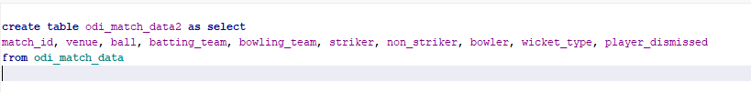

Created new table with only relevant columns from original data. I then want to filter the data to only include records with players that are subject to certain conditions to ensure only mainstream players are inside the database.

I created a new table in my SQL database called players, which should store player information inside, I have specified their name, country, and if they are a bowler or a batsman.

This should select all of the batsman who have more than 300 runs and are from mainstream cricketing nations.

I will then need to insert this into the players database with bowler as 1 and batsman as 1.

This then inserts the data into the players database.

I have done the same thing for the bowlers, but I have also added some additional conditions since these wicket types aren’t a wicket for the bowler. This should insert all the bowlers with more than 20 wickets.

After browsing the player’s database, I came across a problem – there are duplicate records if a player has taken over 20 wickets and has over 300 runs. Hence, this will mean that I will need to create a new classification, which is allrounder and merge these 2 records together. The player will be an allrounder if isBatsman and isBowler are 1.

For each allrounder, I set the isBatsman and isBowler property to 1, as I have filtered the records where the name appears more than once. However, this does not fix the problem of the duplicates in the database. I could not find a way to do this in the end, so I copied and pasted some code to do this from <https://stackoverflow.com/questions/20963887/deleting-duplicate-rows-in-sqlite>.

I adjusted this for my own code, but I had to make sure to reseed the database first to ensure that the ids are in order, and there are no gaps in the ids as I delete records.

I then executed the code to remove duplicates.

I then ran the above statement to make sure that there were no duplicates, and there are 0 rows returned so there are no duplicates. I will need to use this later when I am creating my UI, to ensure that a minimum of 5 bowlers + allrounders are picked. I also used the players database to remove all the records in the main database where the bowler or the striker are not in the players database.

This deletes all the records in odi_match_data2 where the striker or bowler are not in the players database to maintain consistency.

The last thing I need to do is to add an integer flag if a wicket fell on a ball, as machine works best with numerical values.

At the top, I created a column of type int is_wicket in the database. I then set it to 0 or 1 depending on if a wicket has been taken.

Now, we can start developing the machine learning model since all of the prerequisites have been completed.

**Machine learning model – Random Forest (Iteration 1)**

My first attempt of a model was using a random forest model, as it is suited to classification and regression problems. It also puts a large focus on feature importance, which is extremely important for cricket, considering bowler, striker etc. It is also not just a simple regression task and requires more robustness which led me to choosing it over a linear regressor.

Importing dataset and storing as dataframe, which allows for greater flexibility and functionality. I then defined the features, which are the factors in which the machine learning model will consider. These are the main factors which should affect the model only, and hence this is why I chose those features. I then defined the target variables, which are the values being predicted, which are the runs and if a wicket is taken.

I then created a transformer, which converts string fields and encodes them into numbers, as ml models are numerical. This means that I had to have additional import statements, as these libraries will handle the implementation for me. I am not importing the whole library mostly as that is inefficient and am only importing the required methods/classes etc from the libraries.A black background with colorful text

I then had to split the data for training and testing.



I split the data 80% for training, and 20% for testing the data, which is the most common industry standard. I then defined the random state for the random forest models that I will be using as 42 as I have seen it used in a lot of tutorials. This random_state does not need to have a specific value, but ensures that the test train split is reproducible, making it easier to follow through the documentation. I also required additional import statements for this task.

I have also included the last two import statements as I am sure that I will need them later when defining the models.

I then defined the models required, for the runs model I am using a regressor as there can be a multitude of outcomes to choose from. I am transforming it using the existing pre-processor. I then defined the wickets model as a classifier because either a wicket can be taken or not, which leans itself more to a classification model. I then fitted both models to the required data.

This is code for testing the model. I am using the mean squared error and the r^2 tests to evaluate the performance of my runs model. The mean squared error measures how close a regression line is to a set of data points. My objective is to have the mse smaller than 2 to minimise error. While this seems like a lot, I am not too worried as the nature of cricket is random, so there should be some error and variation. The R^2 measures the goodness of the fit against the test data. For the program, my objective is to have an R^2 greater than 0 to ensure that it is better than a mean based model.

This is the wickets performance evaluation. I am using accuracy instead of r^2 and mse since it is more suited to classification problems, since only the difference between the expected outcome and the real outcome matter. The objective for this accuracy is to be larger than 0.90 to ensure it is predicting the outcome the best as it can.

Updated import statements to include performance metrics.

Set the values to round to 4dp to stop seeing large number of significant features which improves readability.

After running the file, and fitting the values, I got these values for the performance metrics:

These metrics are not great, and they show that my model will need to be adjusted to improve model performance, as it does not meet my objectives. Compared to the runs and r^2, the wickets model is comparatively decent but still requires adjustment.]

Just create some values which are better than the previous one but still not great.

For now, I will only change the features inside the machine learning model as it may be overfitting the data. I have changed the features as seen below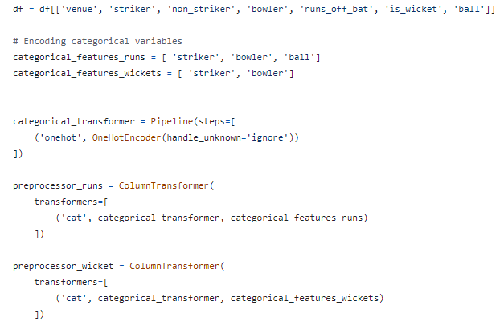

I have removed some of the more specific features, and set different features for both runs and wickets since they depend on different factors, and wickets are not too specific to the ball number. The rest of the code remained the same, and I just had to define my models using the pre-processor for the runs model as preprocessor runs and the wickets model as preprocessor wicket.

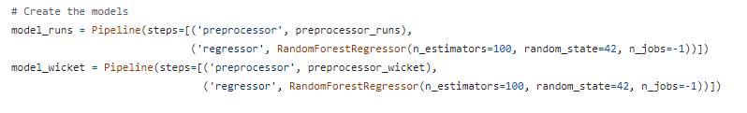

Here I have defined the models, and I have changed some of the parameters. I have set both to regressors to get a probability out, as the model was always predicting no wicket since the probability of wicket is so low. The n_estimators is the number of decision trees used in the model, a larger number means the model is theoretically more accurate, while n_jobs = -1 sets the model to use all cores for training, which speeds up training by a large amount.

I did have to adjust the code for my wickets model since I cannot use accuracy as a performance metric since I am now using a regression model. Hence, I updated the code to use r^2 instead.

I ran this code and once again the values were not great.

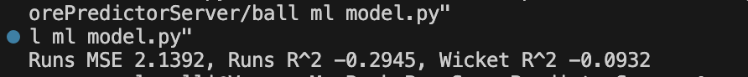

The runs mean squared error was greater than the previous attempt, but only marginally. However, the runs r^2 has improved, and this r^2 value is more important than the mse value. The wickets r^2 is not ideal, and that suggested that a regressor is not a good model to use for this at all. In conclusion, this suggested that I needed more features to make my model more accurate.

Hence, I will dynamically calculate some statistics and I will merge them inside them in my existing dataframe.

I am initialising a column balls faced, which will help me to look at overall statistics. I am also creating a column called is_out, which will show 1 if the player is out to simplify later calculations.

This piece of code creates a sub dataframe of the main dataframe, and gets the total runs, balls, and number of times out for batsman. I am then calculating the strike rate and the number of times they are dismissed out per ball.



I then have defined the bowler to have a wicket when the wicket type is inside the selected categories, and have set it to 1 if there is a wicket and 0 otherwise.

I have then done something similar to the batsman statistics for the bowlers, as I want to calculate the bowler strike rate and the bowler economy rate.

I then calculated the bowlers’ statistics using a lambda expression, and if there is no data, I am replacing it with nan values, to avoid zero division errors. I am then replacing the infinite or nan values with None to show that they do not have enough data.



I am then merging these metrics back into the original database for use in the machine learning model when defining features etc.

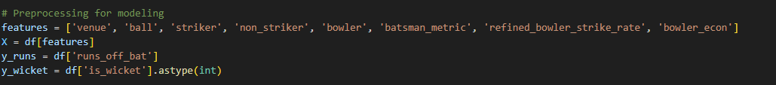

Redefining features with new features added into the dataframe for modelling.

Redefined preprocessing with new features inside preprocessor to ensure that data is transformed correctly. I have then redefined the model and have used a classifier for the wickets instead of a regressor since a regressor was not accurate at all.

I then fitted the models and then calculated the performance metrics.

As you can see, this model is a large improvement over the previous models with the R^2, MSE and the accuracy. However, the r^2 is still negative, and the MSE is still quite high. Another problem with this model is that it has taken quite a lot of time to calculate the statistics at the beginning of the program very time and is worsening run time. Hence, I think I should pre calculate them and store them inside the players database.

Hence, I will add a couple of features to my players dataset to capture the relationship better to improve model performance. These are the runs scored per ball, the no. times dismissed per ball for the batsmen, and the wickets taken per ball, and the runs conceded per ball for the bowlers.

Adding the columns to the players database, indicating which data type – I have used real since the values are decimal values.

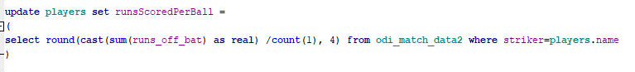

This is the query to update the runs scored per ball column. Originally this was not working, however I realised that I had to set the runs off bat to real to be expressed as a real number in the final calculation. I have rounded the value to 4dp to prevent excessively long values.

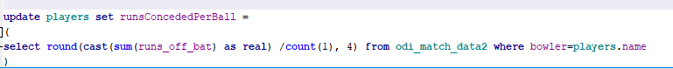

I employed a similar strategy to calculate the runs conceded per ball but changed the striker to bowler. This should be null if a player has never bowled.

This is the statement to get the number of times a striker has been dismissed and divides it by the number of balls they faced. This is slightly more complicated, and how it works is it joins the number of balls faced to the player inside the player database, where the a and b act as aliases. It then sets this dismissed per ball category to the value calculated.

This is essentially doing the same for the wickets query to calculate the wickets per ball for the bowlers. This uses the same inner joins and principles as the one above but excludes retired hurt and run out since they don’t count towards the bowler’s wickets.

The last thing I will do is add a phase attribute for the records in the main dataset. The phase is the region of play in which a ball is being bowled. The first 10 overs have phase 1, 10-20 phase 2 and so on such that there are a total of 5 phases.



Adding phase column into database and specifying integer type.

I used a simple switch case statement to set the phase for each record. Since the ball was represented as a float, this meant that I could use simple inequalities. This prevented model overfitting and was more general, which would fare better in the model performance metrics.

I have here repeated the same preprocessing and model definitions as earlier, but I have now included phase in the model, and I have got rid of some other features that weren’t so helpful, like the factors I have calculated earlier. I decided to implement these at a later stage since I thought that adding the phase column individually might allow me to see its individual effect more clearly.

I then trained my model once again, and I found the performance metrics as below:



All the performance metrics have improved due to this, as the model stopped overfitting to individual balls. Another way I can improve these performance metrics is if I now include the batsman and bowler statistics I had stored in my players database earlier.

I loaded both datasets into my program as different identifiers. I then took the runs scored per ball and the dismissed per ball and merged it with the main dataset, with the associated striker of a record. I did the same for runs conceded per ball and dismissed per ball but instead merged with bowler for a record.

I then defined the features as normal but included the statistics inside the players dataset. I then defined the target features and the preprocessor. The rest of the code remained the same and did not change. I then calculated the same performance metrics after fitting the data and training it. These were the performance metrics as calculated:

As you can see, the metrics have improved, but they still do not meet my criteria, as the r^2 should be larger than 0 ideally. I could not think of any more features I could add to make my model more accurate, so I started thinking that a random forest model may not be the best model to make my predictions. After doing some research, it appeared that gradient boosting may be a better alternative to random forest. After some online research, I started to implement it in my model.

All the preprocessors and feature definition remained the same, and I did not have to write new code, so I copied and pasted it from my old versions. I started working on a new file for this.

The only change so far, I have had to make is transforming the data before, as gradient boosting does not require a pipeline, so I cannot transform my values inside my model, so I must define it before.

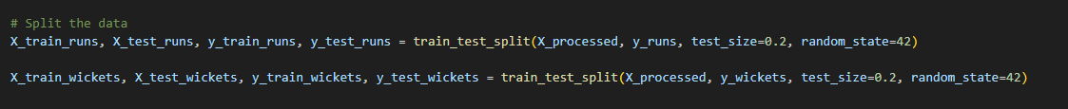

Here I split the data in 20:80 ratio as used previously.



Here I have defined the model, using an XGB regressor. I have defined the objectives in both cases, which is to minimise squared error and for a classification model in the wickets model. I have then defined the hyperparameters, which are the specifications of the model, which I may have to adjust later to improve performance.

Here I have adjusted my import statements to only keep imports that are being used in the program, or libraries that will be required for use later. I am using XGBoost for my gradient boosting model and am using joblib to save and store my model, which saves time as retraining the model every time it is run takes a while.

Here I have tested the model against the test data and have calculated the mse, r^2 and accuracy for the wickets model. For the wickets model, I had to change it to a simple classification problem since I am using a regressor, and hence I defined a simple binary system for the model to be tested against. These were the performance metrics outputted:

As you can see, these values have improved greatly, they now meet my criteria. Preferably, I would have liked the R^2 and runs mse to be better, but due to time constraints and complexity I decided to stop trying new models here. However, one thing I can do is vary my hyperparameters to get better results. For this, I will be using a gridsearch, which will iterate through each combination of chosen hyperparameters.

I defined my parameter grid, and assigned various values to the hyperparameters I will be using.

I then used the grid search with the objective of reducing the mse.



I found these to be the best hyperparameters for use in my model.



I then redefined the models with the best hyperparameters to maximise performance.



I then recalculated the performance metrics, and they were marginally better than last time, but nevertheless still an improvement.

Storing models as files so won’t have to be retrained every time.

Loading the model from saved file. I then commented a lot of redundant code since the model was already stored.

The next step is to build the simulation method when data is sparse. For this, I created a new file, sparse_distribution. I then defined a function to simulate the outcome when data is sparse.

I imported the necessary modules and defined the function, with inputs as striker and bowler. I then stored the dataset as a dataframe.

I then filtered for records with the specified striker, and counted each outcome for the striker, and I normalised them, so the probabilities sum to 1 to ensure a clean integration with the bowlers’ distribution.

I then stored all possible outcomes inside a list run_values. This entire function was very complicated to code, so I made sure to comment all parts of my program to ensure maximum readability.

I then replicated the same thing for the bowler as well and stored the possible outcomes inside run_values_bowler to differentiate them.

I then averaged the probabilities for each outcome between batsman and bowler and normalised them to ensure that the probabilities sum to 1.

I then picked an outcome randomly using the given probabilities and returned the value back.

However, there were some issues with this function that I had not considered in the design stage. Missing values were causing my function to error as it could not handle null values. Another bigger mistake was that the outcomes could sometimes mismatch for the bowler and the batsman. Hence, I will need to sort my outcomes to counter this issue.

This sorts the outcomes and ensures that the index of each outcome matches the index in the other probability distribution. This should mean hat there are no outcome mismatches anymore.



I then fixed the missing values problem by filling in missing values with 0 instead, such that no error should occur. I then ran this function using these parameters and outputted the result. I added the probability distribution to the return statement.

These were the results. I will double check this by running a sql query to find the probability of getting a 0.

The values I have got are 3051, 2018, 1244 and 1645. I used a calculator, and I obtained a probability of 0 as (1645 /3051 + 1244/2018) /2. This equalled

This meant that my function was working as expected.

I also need to do something similar for the wickets section, but it will be a lot easier since it is just a classification problem so I will do that inside my main function.

The next thing I need to do is define when data is sparse. For this scenario, I am defining sparse data is data where the number of records between the striker and bowler is smaller than 4 or there are no records inside a specific phase.

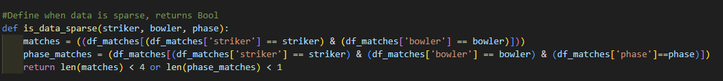

This is the function, I am counting all the records, and returning a Boolean depending on the condition that I have specified above.

Phase calculation function using simple modulus method.

The next step I need to take is to define the simulate ball function for when data is sparse.

I then defined this function with the appropriate parameters. I have then filtered for the batsman stats such that the specified records in the players dataset are retrieved. I am then storing the predicted runs to the function call simulate outcome, which I have defined previously.

Here I am doing my wicket prediction, as I have just averaged the dismissed per ball and wickets per ball to get a probability. This is possible since there are only 2 outcomes – wicket or no wicket. I am then return the predicted runs and the wicket probability.

I next need to define a simulate ball function that will integrate this with the machine learning model prediction.

I have defined the simulate ball function with appropriate parameters and have set the wicket probability to 0 so that it can be used later.

If data is sparse, I am just calling the function to get a runs prediction and wicket probability.

Here I am getting the runs scored per ball and all other similar attributes for the specified bowler and striker. I have filtered the dataset in order to do this.

I have then created an input dataframe with the specified columns and features. I have then transformed the dataframe to be in the format used for machine learning using the preprocessor. I have then predicted the runs and wickets using this method.

I am then doing a simple random condition for is_wicket, as I am comparing the probability to a randomly generated value between 0 and 1. If its greater than the probability, then there is no wicket and vice versa.

If there is a wicket, I have set the runs to 0, and removed the possibility of a 5 and replaced it with a 6. I chose 6 because it is close to 5, and the machine learning model would theoretically predict less 6s than expected since it is a regressor.

Returning values

I then created a function to simulate the over and update the overall statistics.

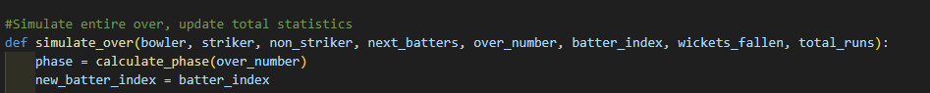

I calculated the phase and set the batter index to the input parameter.



Simulating runs and wicket for each ball.



Calculating ball number for display option.

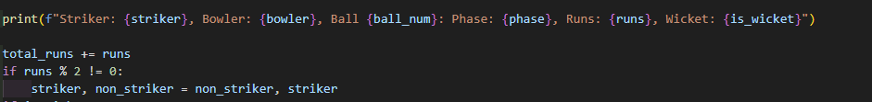

Printing ball outcome and changing striker if odd number of runs scored, also updating total runs.

I then had to define a stopping condition if 10 wickets had fallen, the simulation should stop. This also sets the striker to a next batsman in the batter list if there are still wickets left, and increments this. If 10 wickets have fallen, it stops.

I am switching the striker and non-striker at the end of the over, and I have returned the changed values within the simulate over function.

I then need to define a simulate innings function that will simulate the entire innings and keep track of overall statistics.

I have initialised all the innings’ stats. I have set the batter index to 1 such that the next batsman becomes striker once a player gets out. I have set the non-striker and the striker to the first two players in the list. A black background with white text

I then defined the main loop of my program, which only runs if less than 50 overs have been bowled and less than 10 wickets have fallen. I am then selecting the bowler by rotating each bowler in sequence, such that each bowler bowls an equal (max 1 over difference) number of overs.

I am setting each innings stats to the values returned from the over simulation.

Incrementing over number and breaking if the batter index exceeds the number of available batters.



Final print statement to display innings statistics.

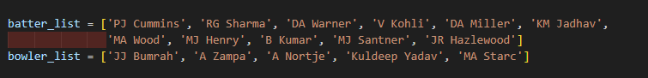

I have defined some players for testing. All the batters are quite strong, and the bowlers are quite strong as well.

I decided to test the simulate ball function independently.

I called this function 10 times with these inputs. I have chosen these inputs since I know that this data is not sparse.

This is a problem since the same result is being returned every time. This is not ideal, as I want to simulate the randomness of cricket. Another issue is that the runs is not a whole number. Hence, I had to solve this problem and the way I chose to do it was to use a Poisson distribution while keeping lambda as the predicted value. This ensures that I get a discrete positive integer value while also adding randomness.

This code uses the poisson distribution with lambda as the predicted runs. This ensures that the mean is the predicted runs, which is ideal.

Running again:

This is a lot more realistic, and its integer values now.



Calling innings simulation. The results were:

This is quite realistic for a cricket match with two very strong teams. While looking through the ball logs, I encountered an issue.

The striker did not go to a new player when Pat Cummins got out. Instead, it seems to have reset to Rohit Sharma.

However, this problem did not exist for latter batsman.

This meant that something was wrong with the initialisation values. After some debugging, I managed to find the root of the problem.

I had to set batter index to 2 instead of 1, as the 2nd player in the list was being picked again if one of the original batters got out. Rerunning the code:

This seemed to work as the striker and non-striker switched after an over finished, and the next batsman in the list became the striker after a player got out.



This is also realistic, and this model is entirely working now according to my criteria. However, one thing I wanted to do in the time being is to display individual player statistics like I have discussed previously.

Hence, I defined a dictionary which contains the statistics for each player.



I have separate dictionaries for batters and bowlers. I have initialised the values to 0 and I have defined the statistics in the dictionary itself.

I then defined functions to update the batting and bowling statistics for a certain player.





I took batsman, runs, is_wicket and bowler as inputs for the batters. I incremented the balls faced and added the runs. If there is a wicket, I set there is_out property to True and added the bowler who dismissed them.

I have done the same thing for the bowlers, and this is quite simple as I am just adding the parameters/incrementing fields, and the calculations will be done at a later stage.

I called these functions at the end of every ball inside my simulate over function.

The last thing I need to handle now is the printing and calculation of the statistics.

Set title to batting statistics and looping through items in batting_stats dictionary.



Calculating strike rate stat and rounding to 2dp to prevent excessive length. I am then printing the desired statistics onto the console. This is for batters who got out.



Calculating strike rate and displaying metrics for batters who batted but did not get out. Hence, the dismissed_by can be omitted.

Just printing did not bat if a batter did not bat at all.

I am doing the same for the bowlers, looping through all bowlers with title at top.

Here I am calculating the number of overs bowled. For example, if 10 balls are bowled, 1.4 overs should be bowled. Hence, I am using a divmod which would allow me to get the whole number and the remainder. This allows me to create the string overs_bowled using this information.

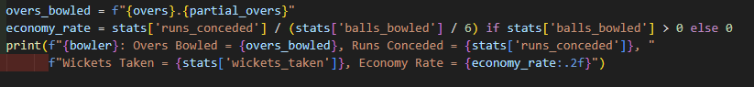

Calculating economy rate and avoiding zero division error by using if condition. Then I am printing all the statistics discussed previously.



Calling this entire function at the end of the simulate_innings function after the innings stats output.

The results of this:

This looks like it has worked, and the economy rate and strike rate all match so they have been calculated quickly. I just checked the dismissed by:

Kohli has been dismissed by Nortje, which matches the stats, and hence the entire function is working as intended.

This means that the entire python program is finished, and the only change required is the method of sending this data across to the WinForms application. The way I though to do this was to use a JSON file and export each ball as a class into a JSON file, which can be interpreted and compiled on the .NET end to calculate required statistics.

Hence, I created a new class and defined a new class, Ball.

I have defined the attributes for each ball, and the input parameters. I have set the input parameters equal to the attributes so the properties can be set through the new constructor method, this also prevents accidental overwriting of the data, as each object is independent of each other.

I then defined a ball list so I can store a list of all the balls.



Inside the simulate over function, I am adding an object of type ball with the defined parameters of the ball to the ball list in order.



I have returned ball_list at the end of the simulate innings function, such that only simulate innings need to be called for the ball_list to be retrieved.

I will now focus on my UI (my WinForms application).

## (ii) TESTING TO INFORM DEVELOPMENT

*(a) Provide annotated evidence for testing at each stage justifying the reason for the test.*

*(b) Provide annotated evidence of any remedial actions taken justifying the decision made.*

# (4) EVALUATION (20 mARKS)

## (I) TESTING TO INFORM EVALUATION

*(a) Provide annotated evidence of testing the solution of robustness at the end of the development process.*

*(b) Provide annotated evidence of usability testing (user feedback).*

## (II) SUCCESS OF THE SOLUTION

*(a) Use the test evidence from the development and post development process to evaluate the solution against the success criteria from the analysis.*

## (III) DESCRIBE THE FINAL PRODUCT

*(a) Provide annotated evidence of the usability features from the design, commenting on their effectiveness.*

## (IV) MAINTENANCE AND DEVELOPMENT

(*a) Discuss the maintainability of the solution.*

*(b) Discuss potential further development of the solution.*

## APPENDIX A - BIBLIOGRAPHY